Firstname Lastname
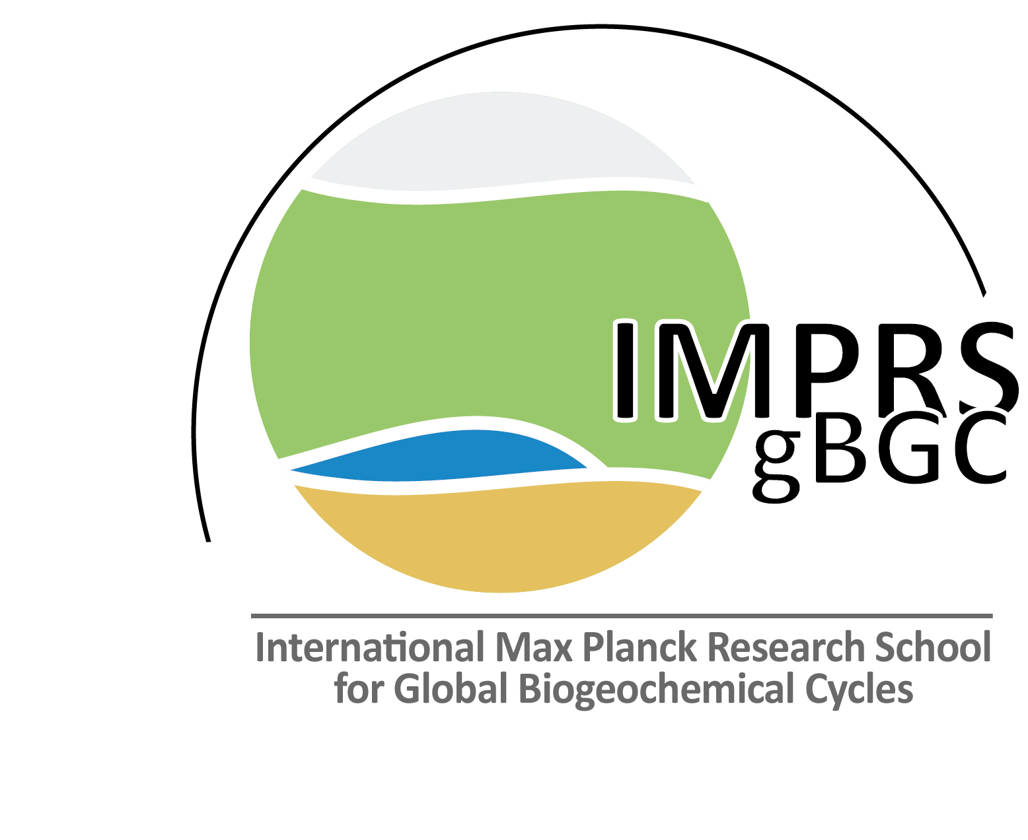

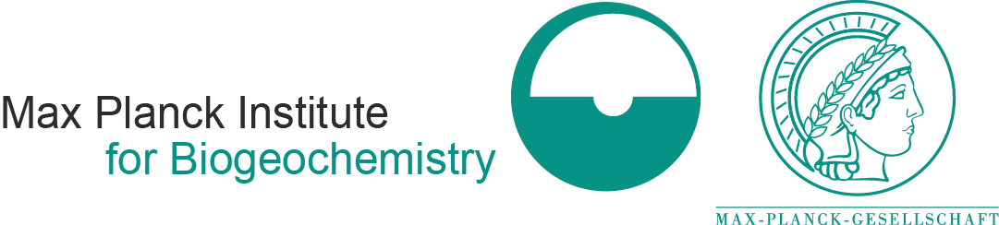
Fulfillment of IMPRS-gBGC requirements so far

as of MONTH, DD, Year

Curricular element |  | credit points (CP) | Min | status
Courses related to global biogeochemical cycles
Overview course* |  | 1 | 1
Core courses⁽¹⁾ |  | 1 per 5-day course | 2
Skill and elective courses |  | 1 per 5-day course | 3
Transferable skills
Good scientific practice* |  | 0.2 per day course | 1
Outreach activities
Presentations at international conferences |  | 1 CP/ talk; ½ CP/ poster | 1
first author publications in international peer-reviewed journal |  | 1 CP/ submitted publication  2 CP/ accepted publication | 1
Non-first-author publication in international peer-reviewed journal |  | 1 CP/ publication | 0
Public outreach (radio, newspaper, public talk, Long Night of Science, ...) |  | 1 CP/ outreach | 1
Other scientific activities
Research visit at foreign research group |  | 1 CP/ month | 3
Active participation in PhDnet, organization of scientific events, active participation in scientific societies, teaching, … |  | depending on effort | 0
Award of an international conference |  | 1 CP / award | 0
∑ CPs from curricular elements specified above |  |  | 13
Total number of CPs necessary to obtain IMPRS-gBGC certificate |  |  | 20^{(2).}.
* mandatory course for doctoral researchers
⁽¹⁾ offered by IMPRS-gBGC
⁽²⁾ The doctoral researcher is free to choose together with PAC how to collect the credit points

