GLOBAL SIMULATION OF GROUNDWATER RECHARGE, WATER TABLE DEPTH, AND LOW FLOW USING A LAND SURFACE MODEL WITH GROUNDWATER REPRESENTATION.

Sujan KOIRALA1, Hannah G. YAMADA2, Pat J.-F. YEH3, Taikan OKI4, Yukiko HIRABAYASHI5, and Shinjiro KANAE6

1Member of JSCE, Dr. of Eng., Researcher, Department of Mechanical and Environmental Informatics, Tokyo Institute of Technology (2-12-1-W8-4 O-okayama, Meguro-ku, Tokyo 152-8552, Japan)
2Member of JSCE, Master of Eng., Department of Mechanical and Environmental Informatics, Tokyo Institute of Technology (2-12-1-W8-4 O-okayama, Meguro-ku, Tokyo 152-8552, Japan)
3 Dr. of Eng., Associate Professor, Department of Civil Engineering, University of Tokyo (4-6-1 Komaba, Meguro-ku, Tokyo 153-8505, Japan)
4Member of JSCE, Dr. of Eng., Professor, Department of Civil Engineering, University of Tokyo (4-6-1 Komaba, Meguro-ku, Tokyo 153-8505, Japan)
5Member of JSCE, Dr. of Eng., Associate Professor, Institute of Engineering Innovation, University of Tokyo (2-11-16 Bunkyo-ku, Tokyo 113-8656, Japan)
6Member of JSCE, Dr. of Eng., Associate Professor, Department of Mechanical and Environmental Informatics, Tokyo Institute of Technology (2-12-1-W8-4 O-okayama, Meguro-ku, Tokyo 152-8552, Japan)

With the withdrawal for anthropogenic uses in addition to climatic changes, the sustainability of groundwater resources is under question. Global-scale land surface models commonly used for water resources assessment, however, simplify or completely neglect the groundwater processes making them inapplicable for groundwater resources assessment. In this study, a groundwater representation is implemented into a global-scale LSM, the MATSIRO, enabling it to simulate the major groundwater variables namely, groundwater recharge, water table depth, and low flow. The estimated global groundwater recharge (29900 km³/yr) corresponds well with GSWP-2 mean baseflow (30200 km³/yr). Global distribution of water table depth is found to be mainly controlled by climate and soil properties. The comparison of simulated and observation-based daily flow duration curves in selected global river basins reveals that the simulation of low flow improves significantly with the groundwater representation.

Key Words : global land surface model, groundwater resources, water table depth, low flow

- INTRODUCTION

Land surface models (LSMs) used for the global-scale hydrologic simulations usually neglect or implicitly represent the groundwater process. The base runoff is often parameterized as a ‘free gravity drainage’ from the soil water storage¹⁾ and hence the major hydrologic variables related to the groundwater process; e.g., base runoff, water table depth (WTD) and groundwater recharge are not simulated in a proper manner. To our knowledge, there is no global-scale modeling study that provides the estimation of all major groundwater variables. Existing global water resources assessments are based on crude annual average due to lack of proper estimation of seasonal variations of runoff²⁾. To reproduce the seasonal variation of available water resources, a proper representation of base runoff or low flow is necessary³⁾.
Furthermore, due to anthropogenic water uses, the groundwater resources is depleting rapidly in various regions of the world, e.g., central United States and northeast India^{4),5)}. Hence, the estimation of groundwater recharge is essential for global assessment of groundwater resources as it indicates the naturally renewable groundwater resources⁶⁾ but its estimations on global scale^{5),7)} are relatively few.
In previous model-based studies, recharge was simulated either as a fraction of total runoff based on slope relief, soil texture, hydrogeology, permafrost, and precipitation intensity, while the upward capillary flux from shallow groundwater was not considered⁷⁾, or as the flux between the lowermost soil layer and groundwater storage, while the dynamic interaction between them was not explicitly modeled⁵⁾. Due to these limitations, an improvement in the model representation of groundwater recharge is desirable.
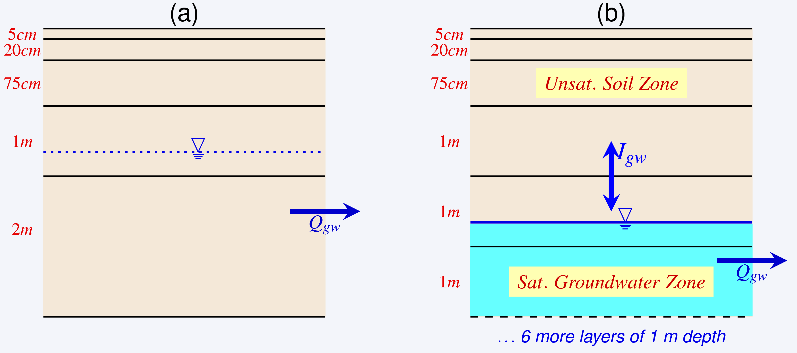
Fig.1 Structure of the soil column in the (a) original MATSIRO and (b) MATSIRO with groundwater representation
Hence, in this study, a dynamic groundwater representation is integrated into a global-scale LSM, the Minimal Advanced Treatments of Surface Integration and runoff (MATSIRO)⁸⁾. With the groundwater representation, the base runoff is generated from groundwater reservoir, WTD is prognostically updated, and groundwater recharge is directly simulated based on Richards’ equation.

- MODEL DESCRIPTION

MATSIRO is the land surface scheme of an Atmospheric Ocean General Circulation Model, the Model for Interdisciplinary Research On Climate (MIROC), jointly developed by the Atmosphere and Ocean Research Institute at the University of Tokyo, the National Institute of Environmental Studies, and the Frontier Research Center for Global Change in Japan. Although the majority of hydrologic processes are physically represented in MATSIRO, it lacks a proper representation of groundwater processes. The structures of soil column and base runoff calculation in the original MATSIRO and MATSIRO with groundwater representation are briefly explained in the following.

(1) Original MATSIRO (MAT-ORI)
Soil column is divided into five layers (Fig. 1a) and the temperature and moisture (liquid and frozen) are calculated for each layer. The thickness of soil layers is 5, 20, 75, 100 and 200 cm respectively.
A simplified version of TOPMODEL⁹⁾ is adopted to represent runoff process. Therefore, WTD is implicitly calculated and does not directly represent the boundary between unsaturated and saturated soil zones. Baseflow is calculated as,
(1)
where Q_{gw} [LT⁻¹] is the baseflow, K₀ [LT⁻¹] is the saturated hydraulic conductivity at ground surface, f_{atn} [L⁻¹] is the attenuation coefficient of K₀ with depth, tanβ_{s} [-] is the mean topographic slope within a grid, and L_{s} [L] is the length of a conceptual hillslope and it is inversely proportional to tanβ_{s}, and d_{gw} [L] is WTD.

(2) MATSIRO with groundwater (MAT-GW)
A simple unconfined aquifer model¹⁰⁾ is coupled to the soil model of MAT-ORI. One-dimensional lumped water balance equation for the unconfined aquifer can be expressed as,
(2)
where S_{y} [-] is specific yield, Δd_{gw} [L] is WTD, Δt [T] is time step, I_{gw} [LT⁻¹] is groundwater recharge to (when positive) or capillary flux from (when negative) the groundwater reservoir, and Q_{gw} [LT⁻¹] is baseflow. The fluctuation of d_{gw} is governed by the difference of I_{gw} and Q_{gw.} I_{gw} depends on the degree of saturation of lowermost soil layer and soil properties. It is calculated as,
(3)
where G_{f} [LT⁻¹] is gravity drainage flux (downward to groundwater reservoir), C_{f} [LT⁻¹] is capillary flux (upward from groundwater reservoir), k [LT⁻¹] is the unsaturated hydraulic conductivity of soil, dψ [L] and dz [L] is difference in matric potentials and elevation of saturated and unsaturated zones.
The size of the groundwater reservoir is dynamic with time and exact location of the water table determines the number of soil layers in unsaturated zone for which the Richards’ equation is solved at each modeling time step. In order to accommodate the variable WTD and accurately locate its position, soil column is extended to ten meters below the ground surface - in total 12 layers with the depth of 5, 20, and 75 cm for the first three layers, and 1 m each for the remaining nine layers. A schematic representation of the linkage of the soil-groundwater model in MAT-GW is presented in Fig. 1b. Unlike MAT-ORI, the soil column now has an explicit dynamic representation of unsaturated and saturated zones separated by the water table, which fluctuates with time.
The TOPMODEL-based baseflow in MAT-ORI (Eq.1) is replaced by the following threshold relationship developed based on observations in Illinois¹²⁾,
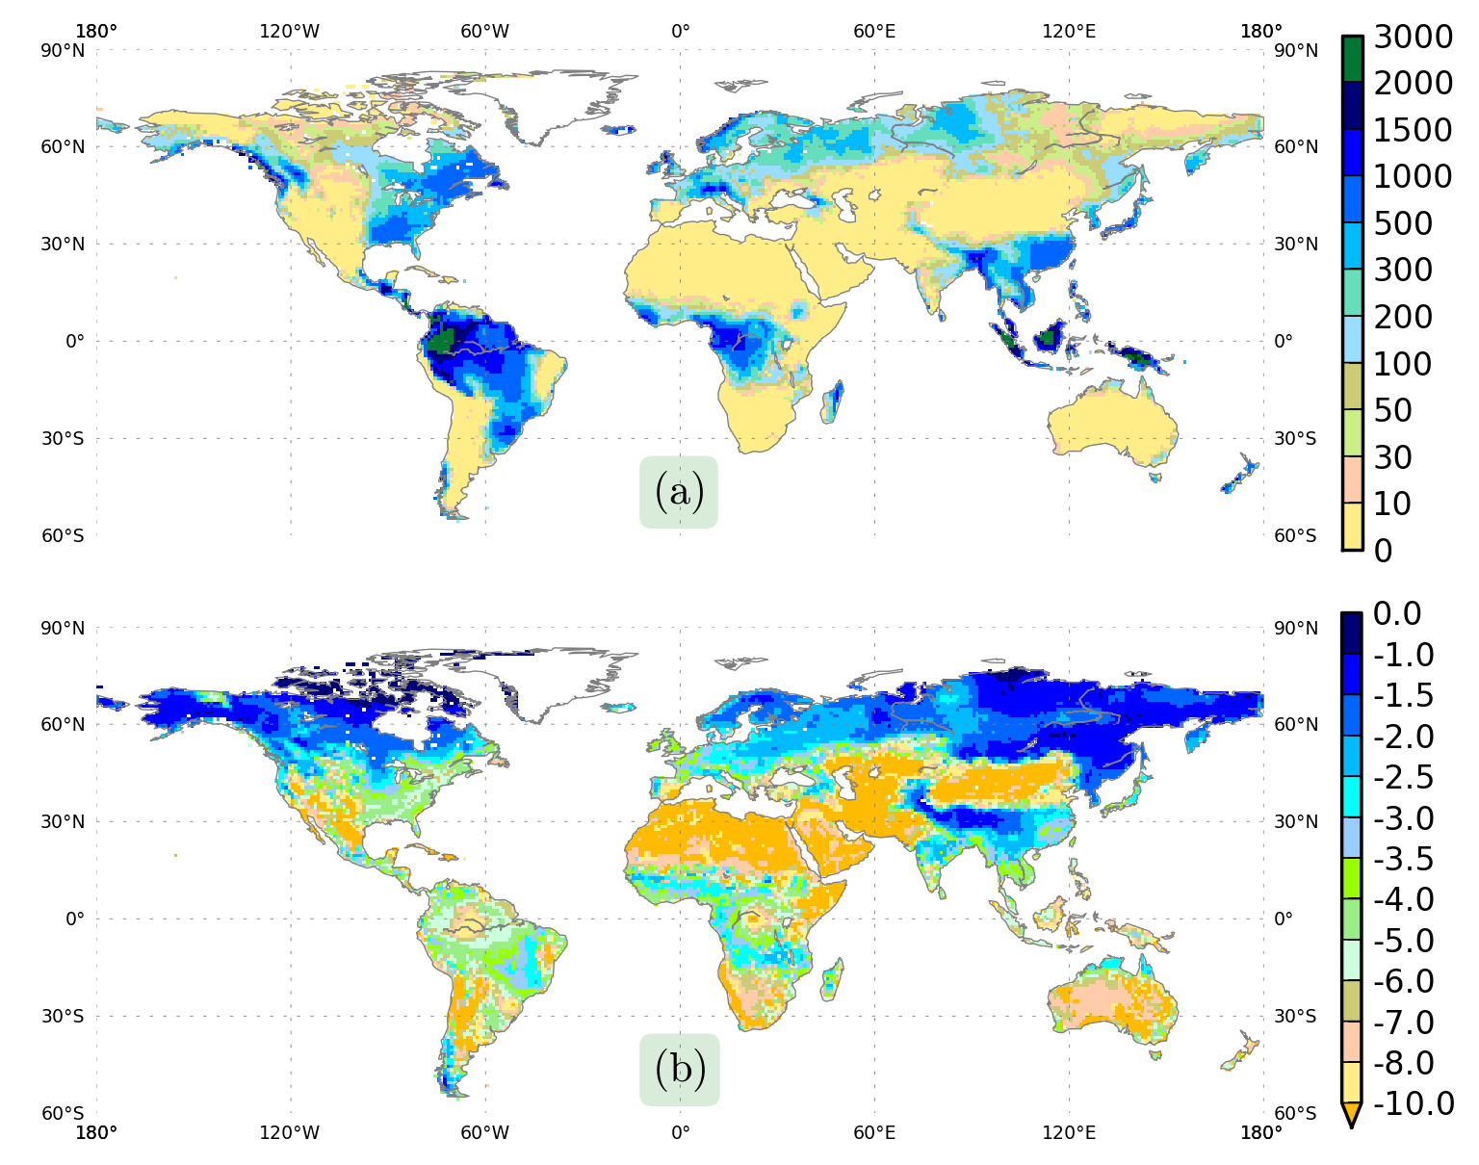
Fig.2 Global distribution map of long-term mean (1985-1999) of (a) groundwater recharge in mm/yr and (b) water table depth in m
(4)

where K [T⁻¹] is the outflow constant, and d₀ [L] is the threshold WTD above which baseflow is initialized. Both d₀ and d_{gw} are taken as positive values during calculation.

- DATA DESCRIPTION

Simulation was driven using the global NCC forcing dataset with 1ºx1º spatial and 6-hourly temporal resolutions¹¹⁾. Simulation is first carried out for a 15-year (1985-1999) period, and the obtained climatologies of hydrologic states are used to initialize another 15-year (1985-1999) simulation for analysis. This procedure is deemed necessary since it usually takes more than 10 years for the simulated WTD to reach equilibrium in the arid regions. The model time step is 1 hour. In addition to forcing data, leaf area index and forest floor albedo were taken from the Global Soil Wetness Project (GSWP-2)¹²⁾. The global distribution of soil was provided by the International Satellite Land Surface Climatology Project- Initiative II (ISLSCP-2). The global distribution of vegetation was provided by the International Geosphere-Biosphere Programme, and vegetation properties were provided by the University of Wales. The parameters related to the groundwater model (d0, K, and Sy in Eq.(2) and Eq.(4)) were estimated at global grid scale using climatic characteristics¹³⁾.

- RESULTS

In this section, the simulations of groundwater recharge and WTD by MAT-GW are discussed first, followed by a comparison of flow duration curves simulated by the MAT-ORI, MAT-GW, and observation by Global Runoff Data Centre.
Globally, mean (1985-1999) groundwater recharge by MAT-GW is 29900 km³/yr. The simulated global recharge volume is larger than previous estimates of 12700 km³/yr⁷⁾ and 15200 km³/yr⁵⁾. In the long term (without human influences), however, the recharge should be balanced by baseflow. The global groundwater recharge by MAT-GW is closer to the GSWP-2 multimodel average baseflow (30200 km³/yr)¹²⁾ than previous estimates^{5),7)}. The global distributions of long-term mean groundwater recharge and WTD by MAT-GW are presented in Fig. 2. Humid regions like the Amazon, Congo and southeastern Asia have the largest groundwater recharge (>1000 mm/yr), while arid and semi-arid regions have small recharge (Fig. 2(a)). In hot (semi-)arid regions, the precipitation is relatively low (0-50 mm/mon), of which 70-85% is found to be evaporated, resulting in small infiltration to soil and lower groundwater recharge. Also, high latitude regions, with frozen ice content in soil > 0.1 m/m, have relatively lower recharge. If the frozen ice content in the root zone is 0.10 m/m, the unsaturated hydraulic conductivity (k in Eq.3) is found to be decreased by 20-25%, depending upon soil type, resulting in lower recharge.
The validation of groundwater recharge and WTD simulation by MAT-GW in the Illinois region has been previously carried out¹⁴⁾. On the global-scale, however, there is no observation data available. As MAT-ORI cannot simulate the recharge, the differences of only MAT-GW recharge simulation and previous model-based country-wise estimate⁷⁾ and statistics-based Food and Agriculture Organization AQUASTAT (FAO) database is presented in Fig. 3. The model-based estimate⁷⁾ was constrained using observed river discharge and is reliable in regions with sufficient observations⁵⁾. Further, the FAO estimate is based on statistical data collected from many countries around the world. The difference between MAT-GW and previous estimates is found to be the largest in the humid countries while it is relatively small in relatively drier as well as cold countries. The largest difference can be seen in the countries located within the humid river basins. In MAT-GW simulation, Amazon basin contributes about 57% of recharge from South America, while Congo river basin contributes 54% of recharge from African continent. Due to limited amount of observation data for calibration of model in these regions, the reliability of previous recharge estimation⁷⁾ is lower and hence the uncertainty in prediction is relatively higher. Nonetheless, the simulation seems to agree fairly well in semi-arid and arid regions where the groundwater recharge is limited and have large risk to be under water stress in future with increasing population as well as the climate change conditions.
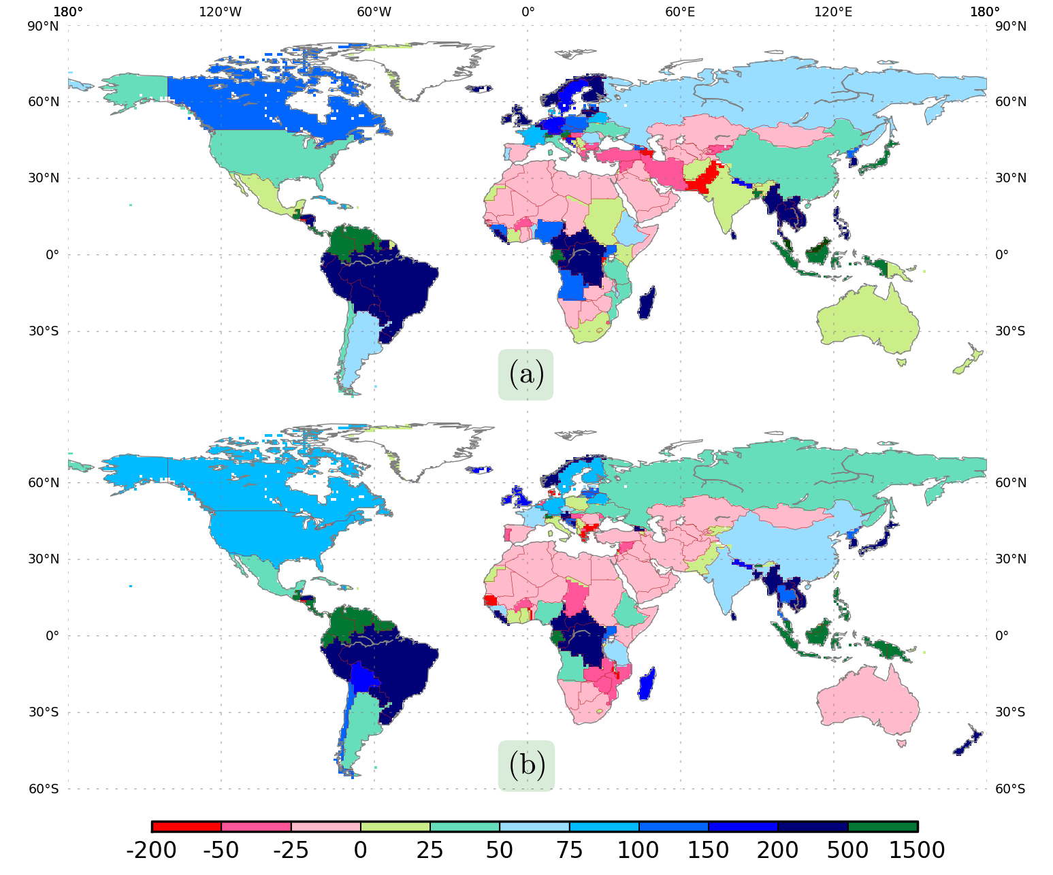
Fig.3 Difference of the MAT-GW simulated groundwater recharge (mm/yr) and (a) FAO Aquastat and (b) previous model-based estimate⁷⁾
Generally, spatial distribution of WTD is controlled by climate, soil and topographical properties¹⁵⁾. A shallow WTD may reflect either large infiltration, governed by climatic condition, or poor drainage condition, governed by soil and topographical characteristics. In Fig. 2(b), the global pattern of MAT-GW simulated WTD is found to be mainly controlled by recharge, baseflow, which are controlled by climate, as well as soil properties.
The spatial distribution of the WTD corresponds with that of climatic characteristics indicated by Budyko dryness index (ratio of net radiation to mean precipitation and has high values for dry regions and low for humid regions) shown in Fig. 4(a). The WTD is deeper in dry regions whereas it is shallower in humid regions. Further, the simulated WTD pattern does not bear any relationship with topography as topographic factors are not considered in calculating the WTD in MAT-GW (Eq.2). Streamflow network (drainage density) and other hillslope terrain attributes also have critical influences on baseflow and WTD. However, these effects work at smaller spatial scales and their control at the grid-size scale of the global simulation may be secondary. As in most LSMs, topography and lateral flow between grid cells are not explicitly considered in MATSIRO. Additional smaller-scale heterogeneities in WTD distribution (Fig. 2(b)) are caused by the difference in soil properties; for example, in the Amazon basin the grid cells with a loamy clay soil usually have a deeper WTD than the clay grid cells (Fig. 4(b)). Under a similar climate, regions with clay or clayey soils may have a shallower WTD compared to sandy soils, as drainage in latter case is more efficient.
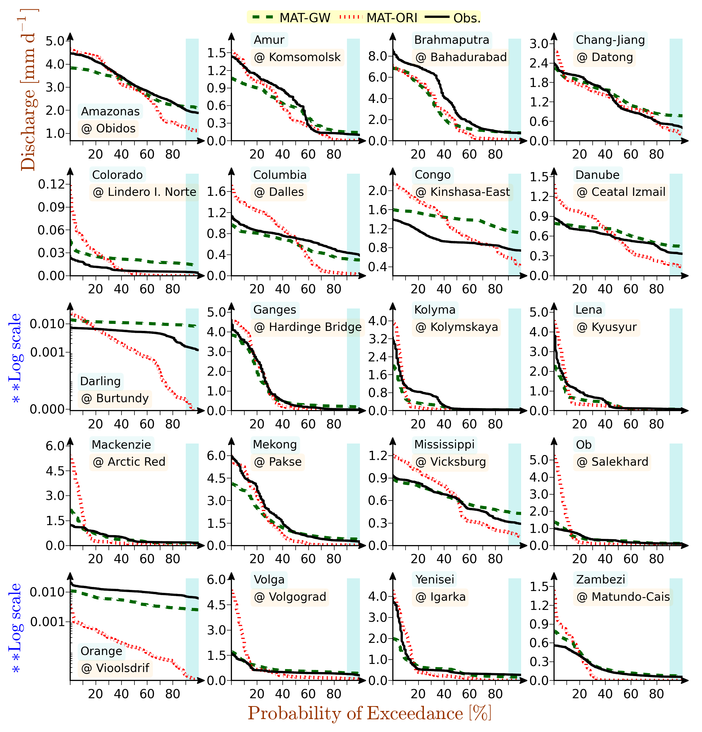
Fig.5 Comparison of daily flow duration curves for MAT-GW simulation (dashed lines), MAT-ORI simulation (dotted lines), and observation (solid lines)
Finally, a comparison of flow duration curves (FDCs) generated from daily flows is presented. A FDC is a plot that shows percentage of the time that flow in a river is likely to equal or exceed some specified value of interest. Daily FDC looks steeper than monthly FDC and it clearly displays the extreme flows. Analysis of flow duration curves is needed to investigate the availability of river discharge; especially in dry season, i.e., low flow. A daily time series of one year was generated from GRDC data available for the study period. Long term mean was used to replace the missing data.
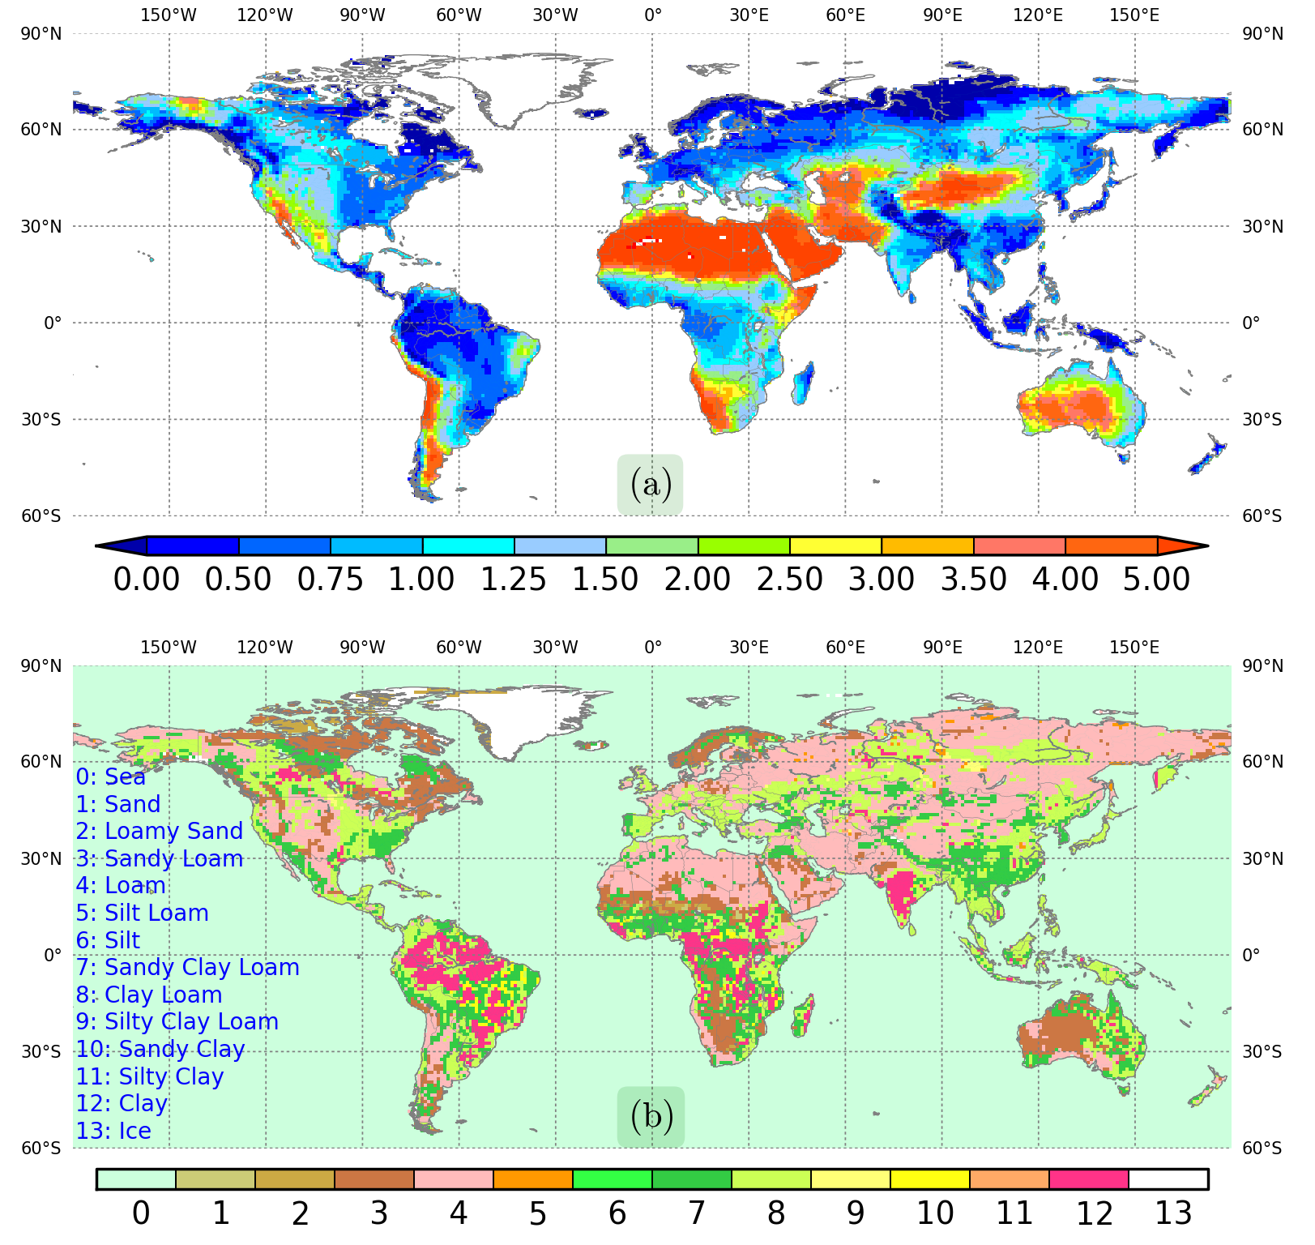
Fig.4 Global distribution of (a) Bukyo dryness index (-) and (b) soil types

The daily FDCs for target river basins are presented in Fig. 5. MAT-ORI cannot simulate low flow correctly for majority of basins. The difference between MAT-ORI and MAT-GW is small for high latitude river basins (e.g., Lena and Kolyma river basins). For humid basins, the MAT-GW simulation of 90th percentile flow (the flow available in 9 out of 10 days) is much closer to observation than the MAT-ORI simulation. Similar improvement can be seen in dry basins (e.g., Darling, Orange, and Zambezi) where surface runoff dominated MAT-ORI simulation cannot produce sufficient base runoff in dry season as there is no parameterization of groundwater reservoir. For Congo basin, none of the parameterizations can reproduce the long term mean observed flow duration characteristic correctly.

5. SUMMARY AND DISCUSSIONS

To our knowledge, a first comprehensive global land surface hydrologic simulations of all the major groundwater related variables were presented. Groundwater recharge, which indicates the potential groundwater resources that can be used without depleting the source, was estimated to be 29900 km³/yr globally. Humid regions have the largest recharge while the dry and cold regions have the lowest. Compared to previous estimates, the recharge was higher in the humid region for MAT-GW simulation but the amount was similar in other regions suggesting acceptable simulations. This implies that the physically-based calculation of groundwater recharge using Richards’ equation can reproduce the previous estimates using a calibrated conceptual model. The conceptual models are considered relatively poorer for assessment of water resources under climate change, when observation is not available for model calibration. Hence, estimation of groundwater variables using a physically-based land surface model enhances the ability for future assessment of water resources.
Further, global WTD distribution was found to be mainly controlled by the climate while secondary control was provided by the soil properties. The result indicates that the effect of topography might be more pronounced in local scale and cannot be observed directly in grid scale of 100’s of km. Finally, the simulation of river discharge was used to calculate the daily flow duration curves. The comparison of flow duration curves for MAT-ORI and MAT-GW with the observation reveals a significant improvement in the simulation of low flow (90th percentile value), especially in the humid regions where base runoff is the significant runoff generation mechanism, and dry regions, where most of the dry season flow is from groundwater storage.

ACKNOWLEDGMENT: The research was supported by CREST project of Japan Science and Technology Agency (JST) and also partially supported by JSPS- KAKENHI, Grant-in-Aid for Scientific Research (S)(19106008), and Funding program for next generation world-leading researchers, JSPS.

REFERENCES
1) Lohmann, D., Lettenmaier, D. P., Liang, X., Wood, E. F, Boone, A. and Chang, S., et al.: The Project for Intercomparison of Land-surface Parameterization Schemes (PILPS) phase 2(c) Red-Arkansas River basin experiment:: 3. Spatial and temporal analysis of water fluxes, Global and Planetary Change, pp.161-179, 1998.
2) Oki, T. and Kanae, S.: Global Hydrologic Cycle and World Water Resources, Science, Vol. 313, pp.1068-1072, 2006.
3) Maxwell, R. M. and Miller, N. L.: Development of a Coupled Land Surface and Groundwater Model, Journal of Hydrometeorology, Vol.6, pp.233-247, 2005.
4) Rodell, M., Velicogna, I. and Famiglietti, J. S.: Satellite-based estimates of groundwater depletion in India, Nature, Vol. 460, pp. 999-1002, 2009.
5) Wada, Y., van Beek, L. P. H., van Kempen, C. M., Reckman, J. W. T. M., Vasak, S. and Bierkens, M. F. P.: Global depletion of groundwater resources, Geophysical Research Letters, Vol. 37(20), pp.L20402, 2010.
6) Doll, P.: Vulnerability to the impact of climate change on renewable groundwater resources: a global-scale assessment, Environmental Research Letters, Vol.4, pp.035006, 2009.
7) Doll, P. and Fiedler, K.: Global-scale modeling of groundwater recharge, Hydrology and Earth System Sciences, Vol. 12, pp.863-865, 2008.
8) Takata, K., Emori, S. and Watanabe, T.: Development of minimal advanced treatments of surface interaction and runoff, Global and Planetary Change, pp.209-22, 2003.
9) Stieglitz, M., Rind, D., Famiglietti, J. S. and Rosenzweig, C.: An Efficient Approach to Modeling the Topographic Control of Surface Hydrology for Regional and Global Climate Modeling, Journal of Climate, Vol.10(1), pp. 118-137, 1997.
10) Yeh, P. J.-F. and Eltahir, E. A. B.: Representation of water table dynamics in a land surface scheme. Part I: Model development, Journal of Climate, Vol.18, pp.1861-1880, 2005
11) Ngo-Duc, T., Polcher, J. and Laval, K.: A 53-year forcing data for land surface models, Journal of Geophysical Research, Vol.110 (D06116), 2005.
12) Dirmeyer, P. A., Gao, X., Zhao, M., Zhichang, G., Oki, T. and Hanasaki, N.: GSWP-2: Multimodel Analysis and Implications for Our Perception of the Land Surface, Bulletin of American Meteorological Society, Vol. 87(10), pp.1391-1397, 2006.
13) Koirala, S., Yeh, P. J.-F., Oki, T. and Kanae, S.: Parameter estimation of a groundwater representation applicable in a global-scale land surface model, Annual Conference of Japan Society of Hydrology and Water Resources, 2010.
14) Koirala, S., Yeh, P. J.-F., Oki, T. and Kanae, S.: Fully Dynamic Groundwater Representation in the MATSIRO Land Surface Model, Annual Journal of Hydraulic Engineering, Japan Society of Civil Engineers, Vol.54, 2010.
15) York, J.P., Person, M. and Gutowski, W.J.: Putting aquifers into atmospheric simulation models: an example from the Mill Creek Watershed, northeastern Kansas, Advances in Water Resources, Vol. 25(2), 2002.
(Received September 30, 2011)

