A Global Modeling of Land Surface Hydrology with
The Representation of Water Table Dynamics, Part
II: Parameter Estimation

Sujan Koirala¹, Pat J.-F. Yeh², Taikan Oki², and Shinjiro Kanae³
¹Institute of Engineering Innovation, University of Tokyo, Japan
²Department of Civil Engineering, University of Tokyo, Tokyo, Japan.
³Department of Mechanical and Environmental Informatics, Tokyo Institute of Technology, Tokyo, Japan.
Abstract: A representation of water table dynamics is integrated into an LSM, the Minimal Advanced Treatments of Surface Integration and Runoff (MATSIRO) in a companion paper [Koirala et al., submitted]. Here, sensitivity analysis of groundwater (GW) model parameters is carried out at both regional and global scales. A simple and efficient global parameter estimation scheme, based on grid-scale precipitation climatology, is then formulated. Hydrological simulations are found to be most sensitive to the threshold water table depth (d0) parameter. Based on the comparisons of multiple calibration objectives (total runoff, evapotranspiration (ET), GW recharge, water table depth (WTD) and top 2 m soil moisture) against direct observations or observation-based estimates in Illinois, the optimal parameters are found to be non-unique, and hence the overall optimal parameter set is identified using a weight-based selection procedure. Global-scale sensitivity analysis reveals that the partitioning of total runoff into surface runoff and baseﬂow has higher sensitivity to d0 than to outﬂow constant (K). A significant correlation (0.59) is found between optimal d0 and mean precipitation in 20 selected large river basins. Thus, d0 can be estimated from grid-scale precipitation climatology. Global river discharge simulation using the estimated d0 yields the Nash-Sutcliffe coefficient (NS) in the range of 0.3-0.8 in the majority of selected river basins. Improvement in river discharge simulations after tuning K, however, is found to be marginal in most basins. Only in Mackenzie and Ob river basins, the NS improves from 0.09 to 0.57 and from -0.05 to 0.4 respectively.
1. Introduction
In land surface models (LSMs), the exchanges of water and energy between land surface and the atmosphere are usually parameterized based on physical principles, but hydrological processes are often conceptually parameterized [Nijssen et al., 2001]. As a result, a number of parameters are introduced which need to be estimated in a proper way (e.g., via calibration) for reliable applications of the model [Duan et al., 1992; Xie et al., 2007]. The Project for Intercomparison of Land-surface Parameterization Schemes (PILPS) experiment phase 2c at the Red-Arkansas River basin concluded that the calibrated models generally perform better than uncalibrated ones [Liang et al., 1998], which justifies the imperative need for an effective parameter estimation scheme particularly for the large-scale LSM applications. Different parameter sets can lead to varying partitioning between runoff and soil water storage and produce different responses in evapotranspiration (ET) [i.e., equifinality, Beven and Freer, 2001; Duan et al., 2006; Lo et al., 2008]. In basin-scale hydrological modeling studies, calibration techniques utilizing multiple regressions of parameters [Abdulla and Lettenmaier, 1997], complex algorithms [Abdulla et al., 1999; Huang et al., 2003; Heuvelmans et al., 2006], advanced statistical methods with complex probability functions [Beven and Binley, 2006], and Monte-Carlo type of simulation [Demaria et al., 2007; Lo et al., 2008] have been attempted. However, these techniques, heavily relying on the availability of observational data and computational resources, may not be feasible for the global-scale implementation [Nijssen et al., 2001].
Parameter estimation in continental to global scale modeling studies are commonly based on a two-step approach: calibration of a subset of model parameters in the river basins with observational data, and then the regionalization of parameters from calibrated basins to data-scarce or ungauged regions [e.g., Nijssen et al., 2001; Doll et al., 2003; Xie et al., 2007; Troy et al., 2008]. Another approach to determine LSM parameters is to develop correlations between parameters and certain land surface attributes such as topography [e.g., Famiglietti and Wood, 1994; Stieglitz et al., 1997; Koster et al., 2000], but this approach is limited to LSMs considering the relationships between topography and hydrological processes in their parameterization. More than often, river discharge is the only available data with suitable coverage used in the calibration. Although available only for a relatively short period, the satellite-based measurements of the terrestrial water storage in the Gravity Recovery and Climate Experiment (GRACE) [Tapley et al., 2004; Swenson et al., 2006; Yeh et al., 2006] have been recently utilized to constrain model simulations [Guntner, 2008; Lo et al., 2010; Werth and Guntner, 2010] as well as to provide estimates of continental-scale river discharge to the ocean [Syed et al., 2009, 2010]. Previous global-scale applications of the LSMs with groundwater (GW) representation assumed constant parameters [e.g., Niu et al., 2007; Lo and Famiglietti, 2011] due to the lack of an efficient global parameter estimation methodology and calibration data.
Whether the assumption of globally constant parameter can lead to an accurate simulation is still unclear. In the companion paper [Koirala et al., submitted], a representation of water table dynamics [Yeh and Eltahir, 2005a, b] has been integrated into an LSM, namely the Minimal Advanced Treatments of Surface Interaction and Runoff (MATSIRO; Takata et al. [2003]). In this paper, the sensitivity of GW parameters of the MATSIRO with representation of water table dynamics (MAT-GW) is global scales, based on which an endeavor is attempted to formulate a simple and efficient parameter estimation scheme for the global-scale application of LSMs. In section 2, the GW parameters in MAT-GW are brieﬂy introduced, and the sensitivity of MAT-GW hydrologic simulations to these parameters is analyzed in the Illinois region. In section 3, the sensitivity of global-scale simulations to GW parameters is investigated before a new global parameter estimation scheme is presented (section 4). This is followed by the investigated at both regional and summary and conclusions in section 5.
2. Groundwater Parameter Sensitivity and Calibration in Illinois

The development and evaluation of MAT-GW is presented in the companion paper [Koirala et al., submitted]. A simple non-linear unconfined aquifer model is dynamically coupled to the soil model in MATSIRO, and baseﬂow from the aquifer is estimated using a threshold-type relationship considering subgrid heterogeneity of water table depth (WTD). As a result, the following parameters associated with water table dynamics are introduced; the threshold WTD d0 [L], outﬂow constant K [T−1], and specific yield Sy [−]. The d0 (always taken as positive) represents a threshold depth to the water table shallower than which baseﬂow is generated. It is a function of climatic characteristics, topographical attributes, and geographical distribution of river networks in a basin. Large (deeper) d0 in general corresponds to humid regions where the regional WTD is mostly above stream level and hence baseﬂow is an important runoff generation mechanism. The rate of baseﬂow is controlled by the outﬂow constant (K), mainly a function of soil hydraulic properties and basin geomorphology (i.e., the connectivity of groundwater to streams). Smaller (larger) K suggests longer (shorter) GW residence time of the unconfined aquifer. The ﬂuctuations of water table about the mean are also controlled by the specific yield (Sy) of the unconfined aquifer as a function of soil hydraulic properties.
The optimal parameter set depends on the model used and calibration objectives [Gupta et al., 1998; Madsen, 2003]. In the following, the sensitivities of three parameters (d0, K and Sy) are first investigated, and then optimal parameter sets with respect to multiple calibration objectives are identified in Illinois. The GW parameters are varied within their reasonable physical ranges (Table 1), from which in total 270 parameter sets are obtained for a Monte-Carlo type of calibration. Simulation is first carried out for an 11- year (1984-1994) period, and the obtained climatologies of hydrologic states are used to initialize each 11-year (1984-1994) simulation used in the analysis with the first year left out as the spin-up period. For the forcing data, external parameters, and model setup, see the companion paper [Koirala et al., submitted]. Simulations of total runoff, ET, GW recharge, top 2 m soil moisture and WTD are evaluated against direct observations (total runoff, soil moisture and WTD) or observation-based estimates (ET by Yeh et al. [1998]; Yeh and Famiglietti [2008] and GW recharge by Yeh and Famiglietti [2009]) in Illinois. The Nash-Sutcliffe Coefficient of Efficiency [Nash and Sutcliffe, 1973] (hereafter as NS) is used to evaluate model performance. For a perfect simulation, the NS is 1. The plot of NS obtained from total runoff simulation using different parameter sets is presented in Figure 1a, where it indicates a large range of NS. The d0 dictates the seasonal variation of total runoff to the largest extent as its relationship with baseﬂow generation is highly non-linear (equation (5) of the companion paper). Increase in d₀ reduces seasonal variations of runoff as baseﬂow dominates over surface runoff. In addition, NS decreases as K increases given a suitable range of d0. As K increases, baseﬂow increases proportionately. NS generally decreases as Sy increases, but the sensitivity is marginal relative to d0 and K. The ET simulation (Figure 1b) is relatively insensitive to GW parameters with NS >0.69 for all simulations. In the humid Illinois, ET depends upon incoming solar energy rather than moisture conditions [Eltahir and Yeh, 1999]. The WTD simulations show that d0 has the largest sensitivity (Figure 1c), while the top 2 m soil moisture simulation shows relatively small sensitivity to all GW parameters (Figure 1d).
The GW recharge simulation has relatively larger sensitivities to d0 and Sy compared to K (Figure 1e), with NS decreasing when d0 is at the low or high end. Only Sy=0.04 and =0.08 can simulate GW recharge well. As shown in Figure 1, the optimal parameter sets for different calibration objectives are found to be non-unique. To obtain the overall optimal parameter set, the 270 simulations of each calibration objective are first ranked from 1 to 270 following the work by Gulden et al. [2008]. The simulation with the highest NS is ranked 1. Since ET simulation is relatively insensitive to GW parameters (Figure 1b) as the difference between the highest (0.72) and lowest (0.69) NS is small, the weight of ranking for ET should be lower.
Therefore, the ranking of each parameter set for each calibration objective is scaled as,
(1)
where i is the parameter set (1-270), j is the calibration objective/variable (1-5), RRi,j is the relative ranking for simulation of jth objective using ith parameter set, Ri,j is the ranking for simulation of jth objective using ith parameter set, NS , is NS for simulation of jth objective using ith parameter set, and NSjmax is the maximum NS for jth objective for all parameter sets. The overall ranking (OR) of each parameter set is then obtained by averaging the relative rankings of all 5 objectives,
(2)
where ORi is the overall ranking of ith parameter set. Ideally, the minimum (maximum) OR can be 1 (270) if one parameter set yields the best (worst) simulation for all calibration objectives considered. The OR for each parameter set is presented in Figure 2. For a given K and Sy, OR decreases (performance improves) as d0 increases from 0.5 to 3.5, and increases when d0 >4.5. No significant differences in OR can be found for different K, so the overall model performance is relatively insensitive to K. For different Sy, OR increases as Sy increases. For a given d0 and K, Sy >0.12 reduces model performance considerably, while the difference between performances of Sy=0.04 and =0.08 is small. The overall optimal parameter set is identified as d0=3.5 m, K=40 /mon, Sy=0.04, with the lowest OR of 2.6. Notice that this unique parameter set produces the best simulations of total runoff and WTD (Figure 1). In contrast, although the set of d0=4.5, K=80, Sy=0.16 simulates optimal ET, the OR is only 142.6. The parameter set yielding optimal simulations of soil moisture and GW recharge have the OR of 153.2 and 7.4 respectively.
3. Groundwater Parameter Sensitivity in Global-scale Hydrological Simulations
The MAT-GW global-scale simulation requires 100 minutes to complete one model-year on the 1ºx1º grid resolution using 8 processing cores on a UNIX supercomputer. Owing to the large computational demand, the number of calibration parameters needs to be minimized. The sensitivity analysis in Illinois (section 2) shows that simulations are significantly more sensitive to d0 than to K and Sy. The d0 is to the first order controlled by climatic conditions. It is a conceptual macroscale (grid-scale) parameter that needs to be determined via calibration whereby the features of macroscale streamﬂow (or more precisely baseﬂow) can be faithfully reproduced by MAT-GW globally. Similar to S_{y}, K is mainly a function of aquifer hydraulic properties as well. K quantifies the rate of groundwater transmission, or the ability of water holding, of the aquifer. Therefore, for the computationally demanding global-scale parameter estimation practice it stands to reason to calibrate K (along with d₀) while keeping S_{y} as a constant within its reasonable physical ranges. S_{y} is assumed to be 0.08 in the current study, which is reasonable as S_{y} varies from 0.02 for clay to 0.27 for coarse sand [Fetter, 1994].
Therefore, sensitivity analysis of global-scale simulations is carried out first for d₀ (varied according to Table 1) as K is fixed at 40, and followed by K as d0 is fixed at 3.5. After that, relationships between identified optimal parameters and basin-scale hydro-climatic variables are explored as a basis of formulating an efficient global parameter estimation scheme.
The simulation period for global-scale sensitivity analysis is 1985 to 1994. Simulations are driven by the NCC forcing dataset [Ngo-Duc et al., 2005] and the same soil and vegetation parameters as in the Global Soil Wetness Project- Phase 2 [Dirmeyer et al., 2006]. Since a preferred initial state of model is different for different models, regions, and parameters used [Rodell et al., 2005], a simulation is first carried out for a 10-year (1985- 1994) period, and the obtained climatologies of hydrologic states are used to initialize each 10-year (1985-1994) simulation used in the analysis with the first year left out as the spin-up period. This procedure is deemed necessary since it usually takes more than 10 years for the simulated WTD to reach equilibrium in the arid regions. For evaluation of river discharge simulations against observations, 20 worldwide large river basins, with the availability of monthly river discharge data from the Global Runoff Data Centre (GRDC) are selected (Figure 3).
The simulated total runoff is routed over global river networks using a river routing model, the Total Runoff Integrating Pathways (TRIP; Oki and Sud [1998]) to obtain river discharge. The ﬂow velocity is fixed at 1.0 m/s globally in TRIP simulations. In global river routing, ﬂow velocities varying from 0.14 to 1.0 m/s have been used [see Oki et al., 1999, Table 1] with a typical global constant of 0.5 m/s in TRIP [e.g., Oki et al., 1999; Alkama et al., 2010]. In TRIP simulations considering delay by groundwater reservoir, however, a larger ﬂow velocity (0.5-1.0 m/s) has been recommended by Decharme et al. [2010]. Sensitivity of simulated total runoff, baseﬂow, and ET to d0 and K is analyzed in the following. For each parameter, the following relative deviation from the mean of all simulations (RDM) is calculated,
(3)
where µ_{mean} is the average of all simulations for a parameter, µ_{i} is the mean of simulation using i^{th} parameter value, n is the total number of parameter values (9 for d₀ and 6 for K , Table 1).
The global distributions of RDM of d₀ and K for three simulated hydrologic ﬂuxes (total runoff, baseﬂow, and ET) are presented in Figure 4. All three ﬂuxes have a higher sensitivity to d₀ than to K. For total runoff simulations, the sensitivity to both d₀ (Figure 4a) and K (Figure 4b) is relatively low in humid regions with relatively large runoff. In semi-arid and arid regions, the sensitivity of total runoff simulations to d₀ (RDM∼80- 100%) is higher than K (RDM <50%). Interestingly, the RDM of K for total runoff is <5% in most regions, in particular <1% in both humid and arid regions. Moreover, the sensitivity of baseﬂow simulations to both d₀ (Figure 4c) and K (Figure 4d) is significantly higher than total runoff. The change in baseﬂow is partially compensated by the opposite change in surface runoff, and hence the net sensitivity of total runoff is reduced. In most regions globally, the RDM of d₀ for baseﬂow simulations is >50%, whereas that of K is <50%. The ET is relatively insensitive to both d₀ (Figure 4e) and K (Figure 4f) with RDM <20% for d₀ and <5% for K in most regions globally. However, ET shows a very high sensitivity to d₀ (∼100%) only in the Sahara desert.
In addition to long-term mean, the sensitivity of seasonal variations of simulated fluxes to GW parameters is also investigated. For each parameter, the following relative deviation of the coefficient of variation RDCV is calculated,
(4)
where CV_{mean} is the coefficient of variation (CV; standard deviation divided by mean) of the average of all simulations, and CV_{i} is CV of simulation using i^{th} parameter value. The global distributions of RDCV of d₀ and K are presented in Figure 5. Similar to RDM (Figure 4), RDCV of d₀ for all three ﬂuxes are higher than that of K. In humid regions, RDCV of both d₀ (<20%) and K (<10%) for total runoff are relatively low. In other regions except arid areas, however, RDCV of d₀ ranges from 30% to 70% for total runoff, while it is only 20%-30% for K. Further, in semi-arid regions the sensitivity of the seasonal variation of total runoff to d₀ (∼50%, Figure 5a) is higher than that of mean total runoff (∼20%, Figure 4a). The high RDCV of d₀ for total runoff is because of the high sensitivity of mean baseﬂow to d₀ in these regions (Figure 4c), even though the mean total runoff is relatively insensitive to d₀. Further, RDCV of d₀ for baseflow is high as large d0 produces large baseﬂow with small seasonal variations. The RDCV of d0 for baseﬂow varies from ∼20% in humid regions to ∼40% in semi-arid regions, and to ∼100% in dry regions, but it is <20% globally for K (Figure 5d). Finally, the RDCV of both d0 (Figure 5e) and K (Figure 5f) for ET are lower than other two hydrological ﬂuxes. It is <20% for d0 in most regions (except for dry deserts), and <5% globally for K.
4. Global Parameter Estimation Scheme
The parameter sensitivity analyses conducted in Illinois (section 2) and at global scale (section 3) consistently indicate that MAT-GW simulation has a significantly higher sensitivity to d0 than to K, and the parameter sensitivity is higher in runoff simulation than ET simulation. Generally, d0 controls runoff components and their seasonal variations to a larger extent than K. For the computationally-demanding global simulations, therefore, d0 can be estimated first by fixing K, and then K can be estimated by fixing d0.
4.1. Correlation between d0 and Basin-scale Hydro-climatology
In the following, the optimal d0 for river discharge simulations in the selected 20 river basins (Figure 3) are identified. The relationships between the optimal d0 and basin hydro-climatic variables are then analyzed as a basis to formulate an efficient global parameter estimation scheme.
In the majority of river basins, NS obtained from river discharge simulations using the optimal d0 vary from 0.4 to 0.8 (Figure 6), which is comparable with the accuracy attained in previous global-scale modeling studies [e.g., Nijssen et al., 2001; Doll et al., 2003]. However, in some river basins [5 (Colorado), 6 (Columbia), 7 (Congo), and 17 (Orange)], NS is negative even with the optimal d0. Colorado and Columbia River basins both have substantial human inﬂuences, which have just recently been considered in MATSIRO [Pokhrel et al., under revision]. Nijssen et al. [2001] also reported difficulties in reproducing observed discharge after substantial calibration in Columbia as well as in Congo basin where Doll et al. [2003] also indicated a relatively weaker performance suggesting a possible inconsistency between climate forcing data and observed river discharge.
In order to transfer d0 to ungauged regions, its relationship with regional hydro-climatic variables is explored here. If such correlation exists, parameters can be estimated without streamﬂow data that are unavailable in many regions globally. To this end, the scatter plots of the optimal d0 and a set of regional hydro-climatic indices are presented in Figure 6.
The correlation coefficient (r) between the optimal d0 and basin-scale mean precipitation is found to be 0.59 (Figure 6a), higher than that between d0 and basin-scale mean discharge (0.48, Figure 6b). Precipitation determines soil moisture, and in turn, controls runoff generation. Wet soil has higher hydraulic conductivity, resulting in large infiltration and GW recharge, shallower WTD and larger baseﬂow. The close dependency of runoff on precipitation forcing in large-scale models [Fekete et al., 2004] may partially contribute to the correlation between precipitation and runoff-related parameters such as d0, at least in the wet regions. Abdulla and Lettenmaier [1997] also used precipitation, among other variables, to regionalize the model parameters in the Red-Arkansas River basin. Further, a scatter plot between the optimal d0 and Budyko's dryness index [Budyko, 1958, 1974] is presented in Figure 6c. Budyko's dryness index, which depicts the relative availability of net radiation, compared to precipitation, reﬂects the climatic characteristics of a region.
Large (small) values of the index correspond to dry (wet) conditions. The correlations between d0 and both Budyko's dryness index and runoff ratio (river discharge divided by precipitation) are found to be negligible (Figure 6c and Figure 6d, respectively).
4.2. Estimation of d0
Based on Figure 6, d0 is assumed to be dependent on grid-scale mean precipitation as a first-order approximation. Due to the lack of a large number of samples (river basins), the following linear relationship can be served as the first guess of d0,
(5)
where d_{0a} is the optimal d0 (3.5 m) identified in Illinois, µ is the mean precipitation in any grid, and µpI is the mean precipitation in Illinois (82.3 mm/mon). The derivation of equation (5) is presented in the Appendix A1. The d_{0a} is then estimated from the global gridded precipitation dataset and used in a MATSIRO-TRIP global simulation to calculate river discharge. The NS obtained from the discharge simulation are compared to that using the optimal d0 in Figure 7 in order to evaluate the efficiency of the estimation scheme. As seen, NS reduces in most river basins when d_{0a} is used, but NS is still >0.3. However, NS remains unchanged in the Colorado (ID=5), Columbia (6), Congo (7), and Orange (17) with negative NS for the optimal conditions. Further, decreases in model performance cannot be generalized with mean precipitation (Figure 7a) as there are similar decreases in NS in basins with different mean precipitation. However, all the basins with the largest decrease in NS [Brahmaputra (ID=3), Darling (9), Ganges (10), Mekong (14), and Zambezi (20)] have a large seasonal variation of precipitation (Figure 7b). In these basins, a large fraction of annual precipitation occurs in wet season which produces large surface runoff. It is found that the d_{0a} estimated from mean precipitation is too large, and hence overestimates baseﬂow. Therefore, d0a should be reduced if the seasonal variation of precipitation is large. The d0 corrected for the seasonal variations of precipitation can be re-formulated as,
(6)
where σpI and σp are the standard deviations of precipitation in Illinois (42.7 mm/mon) and any grid respectively. The derivation of equation (6) by considering the CV of precipitation is presented in Appendix A2.
Another set of MATSIRO-TRIP global simulation is carried out using d_{0b} to calculate in Figure 8. Simulation using d_{0b} achieves the performance level of simulation using the optimal d0 in the majority of river basins (Figure 8a), and it also significantly improves the simulation compared to that using d_{0a} (Figure 8b). The largest improvement can be seen in the Brahmaputra (ID=3), Ganges (10), and Zambezi (20), all with strong seasonal variations of precipitation. The NS decreases only in the Mackenzie (13) and Ob (16) out of 20 selected basins when using d_{0b} compared to that using d_{0a} or the optimal d0. The precipitations in these two basins have low seasonal variations, and d0a might have been subjected to over-correction after using equation (6). In the majority of selected river basins, d_{0b} is able to achieve the performance level (NS=0.3-0.8) of the calibrated optimal d0, and that attained in previous global-scale modeling studies [e.g., Nijssen et al., 2001; Doll et al., 2003]. The global distribution of d_{0b} is plotted in Figure 9, where it shows that d0 is large (deep) in humid regions, while it is small (shallow) in dry regions. Using this parameter set, regions with large (small) precipitation produce large (small) baseﬂow, as a deep (shallow) d0 implies relative ease (difficulty) for baseﬂow generation. In regions with similar mean precipitation, the variability in d0 is provided by considering seasonal variations of precipitation (equation (6)). Regions with stronger seasonal variation of precipitation tend to produce higher surface runoff in wet season as estimated d0 is reduced. Hence, the estimated d0 by using equation (6) implicitly reproduces dominant runoff generation mechanism based on precipitation characteristics.
On the other hand, estimated d0 does not bear any relationship with topography, which is not explicitly represented in the model parameterization and parameter estimation. The topography has a larger control on local to regional scale hydrology, while its effect may not dominate in the typical grid-scale of global LSMs.
4.3. Estimation of K
In the following, the inﬂuence of adjusting K in river discharge simulations is evaluated by comparing with river discharge observations in 20 selected river basins. The K producing the optimal river discharge simulation is identified in the selected basins. The NS obtained using optimal K is compared with that from base case (K=40) in Figure 10. In the majority of river basins, the low sensitivity of river discharge simulation to K can be observed. Brutsaert and Sugita [2008, p. W02409] suggested that runoff from a large basin can be relatively insensitive to the drainage time scale in the macro-scale modeling as many controlling effects compensate and average each other out. Further, in 9 out of 20 river basins, the optimal K is 20 (/mon), and in 6 other basins, it is 40 (/mon), suggesting that K in different basins with similar hydro-climatic characteristics are of similar magnitude and vary within a narrow range, consistent with the conclusion by Brutsaert and Lopez [1998] and Brutsaert [2008]. Time delay factor for a GW reservoir, of a magnitude similar to the current study was used globally by Decharme et al. [2010] as well. However, a significant improvement is found in the Mackenzie (ID=13) and Ob (16) River basins after adjusting K (NS improves from 0.09 to 0.57 and from -0.05 to 0.4 respectively). For the same basins, NS decreases significantly (Figure 8b) when d0 is adjusted to consider the seasonal variations of precipitation (equation (6)). Therefore, in certain regions, K can be used to fine-tune the simulations once the optimal d0 has been properly estimated. In summary, the overall improvement in global-scale hydrologic simulations by adjusting K is relatively marginal. Therefore, for the present study another global estimation scheme for K, in addition to fine-tuning, is considered to be secondary.
As the optimal K is found to be 20 (/mon) in the majority of selected river basins, this value is used in the regions where K has not been directly calibrated.
5. Summary and Conclusions
Global applications of LSMs with GW representation usually assume globally constant parameters [e.g., Niu et al., 2007; Lo and Famiglietti, 2011] due to lack of an efficient global parameter estimation scheme and calibration data. In this study, a sensitivity analysis of the GW-associated parameters in the MATSIRO LSM is carried out at both regional and global scales. A simple and efficient global parameter estimation scheme based on grid-scale precipitation climatology, applicable for computationally demanding global-scale LSMs is then formulated and implemented in global-scale modeling.
Sensitivity analysis carried out in Illinois with a comprehensive observational hydrological data indicates different sensitivities of hydrologic simulations to GW parameters. Total runoff, WTD, and GW recharge show higher sensitivities to GW parameters than ET and soil moisture. Sensitivities of all hydrological simulations are higher to threshold WTD (d0) than to outﬂow constant (K) and specific yield (Sy). Also, the optimal parameter set is found to be non-unique for different calibration objectives.
On the global-scale simulation as well, total runoff and baseﬂow show higher sensitivities to GW parameters than ET. Among the parameters, d0 has higher sensitivity than K. Baseﬂow simulations show a ∼70% spread for different d0 in semi-arid regions, while that for K is <40%. However, the uncertainty in baseﬂow simulations does not propagate to total runoff as the change in baseﬂow is partially compensated by the opposite change in surface runoff. Due to its higher sensitivity, optimal d0 is first identified in the 20 selected large river basins. Comparison of the optimal d0 with hydro-climatic indices in selected basins reveals a correlation of 0.59 between d0 and mean precipitation. Simulations using d0 estimated only from mean precipitation shows significant decrease in model performance. Therefore, the estimated d0 is corrected to consider the seasonal variations of precipitation. The simulations using corrected d0 depicts model performance similar to the simulation using optimal d0 (NS=0.3-0.8), and hence it is considered to suffice for the present study.
Finally, simulations are conducted for different K and a fixed d0. 15 out of 20 river basins have the optimal K between 20 to 40 (/mon). A similar narrow range was also reported by Brutsaert and Lopez [1998] and Brutsaert [2008]. The comparison shows marginal improvement in river discharge simulations in the majority of selected river basins, suggesting that the sensitivity of hydrological ﬂuxes to GW properties decreases as the spatial scale increases, which is consistent with the conclusions by Brutsaert and Sugita [2008]. Although another global estimation scheme for K is not formulated in this study, K can be adjusted to improve simulations after a proper determination of d0.
Since the parameter is estimated from precipitation climatology available in global scale at a grid-cell resolution, its regional variability can be reasonably represented in global-scale simulations, which is an advance from previous continental to global scale modeling studies assuming constant parameters. The estimated parameters produce large (small) baseﬂow in humid (dry) regions while ensuring large surface runoff generation in the regions with a strong seasonal variation of precipitation (e.g., the Brahmaputra, Ganges and Zambezi River basins).
Appendix A: Equations for Estimation of d0
A1. Calculation of d0 from Mean Precipitation
The d0 is assumed to be proportional to mean precipitation as,
(A1)
where µp is the mean precipitation and k p is the constant of proportionality. Mean precipitation and the optimal d0 are known in Illinois, so k p can be estimated as,
(A2)
where d_{0I} and µpI are the optimal d0 and mean precipitation respectively in Illinois. Combining equation (A1) and equation (A2), d0 for any grid can be estimated as,
(A3)
A2. Correction of d0 for Seasonal Variation of Precipitation
The d0 should be corrected for regions with strong seasonal variation of precipitation. The correction factor (Cf) is assumed to be inversely proportional to coefficient of variation (CV; standard deviation divided by mean) of precipitation as,
(A4)
where k c is the constant of proportionality, µp is the mean precipitation, and σp is the standard deviation of precipitation. In Illinois, µp=µpI and σp=σ pI are both known, and Cf =1 as there is no need to correct d0. Therefore, kc can be estimated as,
(A5)
Putting the value of kc from equation (A5) into equation (A4), Cf can be estimated as,
(A6)
The correction factor should be applied to previously estimated d_{0a} (equation (A3)) as,
(A7)
Finally, combining equations (A3), (A6), and (A7),
(A8)
Acknowledgments. The first author acknowledges the support of the Ministry of Education, Culture, Sports, Science and Technology (MEXT) during his Ph.D., and Core Research of Evolutional Science & Technology (CREST) project of Japan Science and Technology Agency (JST) afterwards. We also express our gratitude to KAKUSHIN Program of the MEXT for supporting the second author. This work was also partially supported by Japan Society for the Promotion of Science (JSPS)- KAKENHI, Grant-in-Aid for Scientific Research (S)(19106008). Finally, we thank Dr. Hyungjun Kim for providing us with the forcing and validation datasets.
References
Abdulla, F. A. and D. P. Lettenmaier, 1997: Development of regional parameter estimation equations for a macroscale hydrologic model. J. Hydrol., 197 (1), 230-257, doi:10.1016/S0022-1694(96)03262-3.
Abdulla, F. A., D. P. Lettenmaier, and X. Liang, 1999: Estimation of the ARNO model baseﬂow parameters using daily streamﬂow data. J. Hydrol., 222, 37-54, doi: 10.1016/S0022-1694(99)00096-7.
Alkama, R., et al., 2010: Global evaluation of the ISBA-TRIP continental hydrological system. Part I: Comparison to GRACE terrestrial water storage estimates and in situ river discharges. J. Hydrometeorol., 11 (3), 583-600, doi:10.1175/2010JHM1211.1.
Beven, K. J. and A. Binley, 2006: The future of distributed models: Model calibration and uncertainty prediction. Hydrol. Process., 6 (3), 279-298, doi:10.1002/hyp.3360060305.
Beven, K. J. and J. Freer, 2001: Equifinality, data assimilation, and uncertainty estimation in mechanistic modelling of complex environmental systems using the GLUE methodology. J. Hydrol., 249 (1-4), 11-29, doi:10.1016/S0022-1694(01)00421-8.
Brutsaert, W., 2008: Long-term groundwater storage trends estimated from streamﬂow records: climatic perspective. Water Resour. Res., 44 (W02409), doi: 10.1029/2007WR006518.
Brutsaert, W. and J. P. Lopez, 1998: Basin-scale geohydrologic drought ﬂow features of riparian aquifers in the southern great plains. Water Resour. Res., 34 (2), 233-240, doi:10.1029/97WR03068.
Brutsaert, W. and M. Sugita, 2008: Is Mongolia's groundwater increasing or decreasing? the case of Kherlen river basin. Hydrolog. Sci. J., 53 (6), doi:10.1623/hysj.53.6.1221.
Budyko, M. I., 1958: The heat balance of the Earths surface. Translated by N. A. Stepanova, U.S. Dept. of Commerce, 259 pp., translated by N. A. Stepanova, U.S. Dept. of Commerce.
Budyko, M. I., 1974: Climate and Life, 508. Academic Press.
Decharme, B., R. Alkama, H. Douville, M. Becker, and A. Cazenave, 2010: Global evaluation of the ISBA-TRIP continental hydrological system. Part II: Uncertainties in river routing simulation related to ﬂow velocity and groundwater storage. J. Hydrometeorol., 11 (3), 601-617, doi:10.1175/2010JHM1212.1.
Demaria, E. M., B. Nijssen, and T. Wagener, 2007: Monte Carlo sensitivity analysis of land surface parameters using the Variable Infiltration Capacity model. J. Geophys. Res., 112 (D11), D11113, doi:10.1029/2006JD007534.
Dirmeyer, P. A., X. Gao, M. Zhao, G. Zhichang, T. Oki, and N. Hanasaki, 2006: GSWP-2: Multimodel analysis and implications for our perception of the land surface. B. Am. Meteorol. Soc., 87 (10), 1391-1397, doi:10.1175/BAMS-87-10-1381.
Doll, P., F. Kaspar, and B. Lehner, 2003: A global hydrological model for deriving water availability indicators: model tuning and validation. J. Hydrol., 270 (1), 105-134, doi: 10.1016/S0022-1694(02)00283-4.
Duan, Q., V. K. Gupta, and S. Sorooshian, 1992: Efective and efficient global optimization for conceptual rainfall-runoff models. Water Resour. Res., 28, 1015-1031, doi:10.1029/91WR02985.
Duan, Q., et al., 2006: Model Parameter Estimation Experiment (MOPEX): An overview of science strategy and major results from the second and third workshops. J. Hydrol., 320 (1-2), 3 - 17, doi:10.1016/j.jhydrol.2005.07.031.
Eltahir, E. A. B. and P. J. F. Yeh, 1999: On the asymmetric response of aquifer water level to ﬂoods and droughts in Illinois. Water Resour. Res., 35 (4), 1199-1217, doi: 10.1029/1998WR900071.
Famiglietti, J. S. and E. F. Wood, 1994: Multi-scale modeling of spatially-variable water and energy balance processes. Water Resour. Res., 30 (11), 3061-3078, doi: 10.1029/94WR01498.
Fekete, B. M., C. J. Vorosmarty, J. O. Roads, and C. J. Willmott, 2004: Uncertainties in precipitation and their impacts on runoff estimates. J. Clim., 17 (2), 294-304, doi: 10.1175/1520-0442(2004)017<0294:UIPATI>2.0.CO;2.
Fetter, C., 1994: Applied hydrogeology. 3d ed., Prentice Hall, Inc., Upper Saddle River, NJ.
Gulden, L. E., E. Rosero, Z.-L. Yang, T. Wagener, and G.-Y. Niu, 2008: Model performance, model robustness, and model fitness scores: A new method for identifying good land-surface models. Geophys. Res. Lett., 35 (L11404), doi:10.1029/2008GL033721.
Guntner, A., 2008: Improvement of global hydrological models using GRACE data. Surv. Geophys., 29, 375-397, doi:10.1007/s10712-008-9038-y.
Gupta, H., S. Sorooshian, and P. Yapo, 1998: Toward improved calibration of hydrologic models: Multiple and noncommensurable measures of information. Water Resour. Res., 34 (4), 751-763, doi:10.1029/97WR03495.
Heuvelmans, G., B. Muys, and J. Feyen, 2006: Regionalisation of the parameters of a hydrological model : Comparison of linear regression models with artificial neural nets. J. Hydrol., 319 (1-4), 245-265, doi:10.1016/j.jhydrol.2005.07.030.
Huang, M., X. Liang, and Y. Liang, 2003: A transferability study of model parameters for the variable infiltration capacity land surface scheme. J. Geophys. Res., 108 (D22), 8864, doi:10.1029/2003JD003676.
Koirala, S., P. J.-F. Yeh, T. Oki, and S. Kanae, submitted: Global modeling of land surface hydrology with the representation of water table dynamics, Part I: Model construction and evaluation. J. Geophys. Res.
Koster, R. D., M. J. Suarez, A. Ducharne, M. Stieglitz, and P. Kumar, 2000: A catchment-based approach to modeling land surface processes in a GCM, Part 1, model structure. J. Geophys. Res., 105, 24809-24822, doi:10.1029/2000JD900327.
Liang, X., et al., 1998: The Project for Intercomparison of Land-surface Parameterization Schemes (PILPS) phase 2(c) Red-Arkansas River basin experiment:: 2. spatial and temporal analysis of water ﬂuxes. Global Planet. Change, 19 (1-4), 137 - 159, doi: 10.1016/S0921-8181(98)00045-9.
Lo, M.-H. and J. S. Famiglietti, 2011: Precipitation response to land subsurface hydrologic processes in atmospheric general circulation model simulations. J. Geophys. Res., 116 (D5), D05107, doi:10.1029/2010JD015134.
Lo, M.-H., J. S. Famiglietti, P. J.-F. Yeh, and T. H. Syed, 2010: Improving parameter estimation and water table depth simulation in a land surface model using GRACE water storage and estimated baseﬂow data. Water Resour. Res., 46 (5), doi: 10.1029/2009WR007855.
Lo, M.-H., P. J.-F. Yeh, and J. S. Famiglietti, 2008: Constraining water table depth simulations in a land surface model using estimated baseﬂow. Adv. Water Resour., 31 (12), 1552-1564, doi:10.1016/j.advwatres.2008.06.007.
Madsen, H., 2003: Parameter estimation in distributed hydrological catchment modelling using automatic calibration with multiple objectives. Adv. Water Resour., 26 (2), 205-216, doi:10.1016/S0309-1708(02)00092-1.
Nash, J. E. and J. V. Sutcliffe, 1973: River ﬂow forecasting through conceptual models part I-a discussion of principles. J. Hydrol., 10, 282-290, doi:10.1016/0022- 1694(70)90255-6.
Ngo-Duc, T., J. Polcher, and K. Laval, 2005: A 53-year forcing data for land surface models. J. Geophys. Res., 110 (D06116), doi:10.1029/2004JD005434.
Nijssen, B., G. M. O'Donnell, D. P. Lettenmaier, D. Lohmann, and E. F. Wood, 2001: Predicting the discharge of global rivers. J. Clim., 14, 3307-3323, doi:10.1175/1520- 0442(2001)014<3307:PTDOGR>2.0.CO;2.
Niu, G.-Y., Z.-L. Yang, R. E. Dickinson, L. E. Gulden, and H. Su, 2007: Development of a simple groundwater model for use in climate models and evaluation with Gravity Recovery and Climate Experiment data. J. Geophys. Res., 112 (D07103), doi: 10.1029/2006JD007522.
Oki, T., T. Nishimura, and P. A. Dirmeyer, 1999: Assessment of annual runoff from land surface models using Total Runoff Integrating Pathways (TRIP). J. Meteorol. Soc. Jpn., 77, 135-255.
Oki, T. and Y. C. Sud, 1998: Design of Total Runoff Integrating Pathways (TRIP)- a global river channel network. Earth Interact., 2, doi:10.1175/1087-3562(1998)002<0001:DOTRIP>2.3.CO;2.
Pokhrel, Y., N. Hanasaki, S. Koirala, J. Cho, H. Kim, P. J.-F.Yeh, S. Kanae, and T. Oki, under revision: Incorporating anthropogenic water regulation modules into a land surface model. J. Hydrometeorol.
Rodell, M., P. R. Houser, A. A. Berg, and J. S. Famiglietti, 2005: Evaluation of 10 methods for initializing a land surface model. J. Hydrometeorol., 6, 146-155, doi: 10.1175/JHM414.1.
Stieglitz, M., D. Rind, J. S. Famiglietti, and C. Rosenzweig, 1997: An efficient approach to modeling the topographic control of surface hydrology for regional and global climate modeling. J. Clim., 10 (1), 118-137, doi:10.1175/1520-0442(1997)010<0118:AEATMT>2.0.CO;2.
Swenson, S., P. J. F. Yeh, J. Wahr, and J. Famiglietti, 2006: A comparison of terrestrial water storage variations from GRACE with in situ measurements from Illinois. Geophys. Res. Lett., 33 (16), L16401, doi:10.1029/2006GL026962.
Syed, T. H., J. S. Famiglietti, and D. P. Chambers, 2009: GRACE-based estimates of terrestrial freshwater discharge from basin to continental scales. J. Hydrometeorol., 10 (1), 22-40, doi:10.1175/2008JHM993.1.
Syed, T. H., J. S. Famiglietti, D. P. Chambers, J. K. Willis, and K. Hilburn, 2010: Satellite-based global-ocean mass balance estimates of interannual variability and emerging trends in continental freshwater discharge. Proc. Natl. Acad. Sci. U. S. A., 107 (42), 17916-17921, doi:10.1073/pnas.1003292107.
Takata, K., S. Emori, and T. Watanabe, 2003: Development of minimal advanced treatments of surface interaction and runoff. Global Planet. Change, 38, 209-222, doi: 10.1016/S0921-8181(03)00030-4.
Tapley, B. D., S. Bettadpur, J. C. Ries, P. F. Thompson, and M. M. Watkins, 2004: GRACE measurements of mass variability in the Earth system. Science, 305, 503-505, doi:10.1126/science.1099192.
Troy, T. J., E. F. Wood, and J. Shefeld, 2008: An efficient calibration method for continental-scale land surface modeling. Water Resour. Res., 44 (W09411), doi: 10.1029/2007WR006513.
Werth, S. and A. Guntner, 2010: Calibration analysis for water storage variability of the global hydrological model WGHM. Hydrol. Earth Syst. Sc., 14 (1), 59-78, doi: 10.5194/hess-14-59-2010.
Xie, Z., F. Yuan, Q. Duan, J. Zheng, M. Liang, and F. Chen, 2007: Regional parameter estimation of the VIC land surface model: Methodology and application to river basins in china. J. Hydrometeorol., 8, 447-468, doi:10.1175/JHM568.1.
Yeh, P. J.-F. and E. A. B. Eltahir, 2005a: Representation of water table dynamics in a land surface scheme. Part I: Model development. J. Clim., 18, 1861-1880, doi: 10.1175/JCLI3330.1.
Yeh, P. J.-F. and E. A. B. Eltahir, 2005b: Representation of water table dynamics in a land surface scheme. Part II: Subgrid variability. J. Clim., 18, 1881-1901, doi: 10.1175/JCLI3331.1.
Yeh, P. J. F. and J. S. Famiglietti, 2008: Regional terrestrial water storage change and evapotranspiration from terrestrial and atmospheric water balance computations. J. Geophys. Res., 113 (D9), D09108, doi:10.1029/2007JD009045.
Yeh, P. J.-F. and J. S. Famiglietti, 2009: Regional groundwater evapotranspiration in Illinois. J. Hydrometeorol., 10, 464-478, doi:10.1175/2008JHM1018.1.
Yeh, P. J.-F., M. Irizarry, and E. A. B. Eltahir, 1998: Hydroclimatology of Illinois: A comparison of monthly evaporation estimates based on atmospheric water balance and soil water balance. J. Geophys. Res., 103 (D16), 19823-19837, doi:10.1029/98JD01721.
Yeh, P. J. F., S. C. Swenson, J. S. Famiglietti, and M. Rodell, 2006: Remote sensing of groundwater storage changes in Illinois using the Gravity Recovery and Climate Experiment (GRACE). Water Resour. Res., 42 (12), W12203, doi:10.1029/2006WR005374.

Table 1. Parameter intervals chosen for the sensitivity analysis.

SN | d0 (m) | K (/mon) | Sy (−)
1 | 0.5 | 20 | 0.04
2 | 1 | 30 | 0.08
3 | 1.5 | 40 | 0.12
4 | 1.75 | 50 | 0.16
5 | 2.25 | 60 | 0.2
6 | 2.75 | 80 | -
7 | 3.5 | - | -
8 | 4.5 | - | -
9 | 7 | - | -

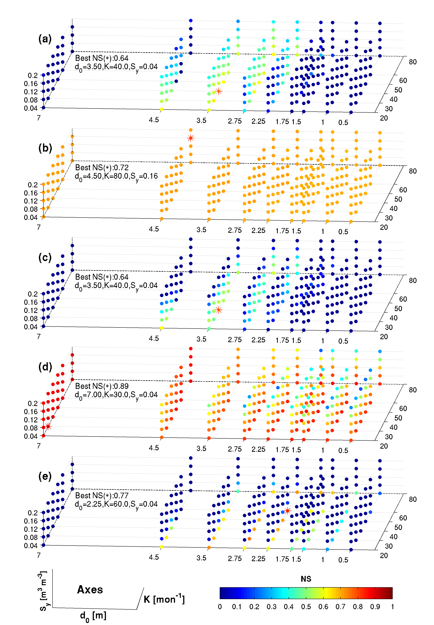
Figure 1. The NS coefficients obtained from the simulations of (a) total runoff, (b) evapotranspiration, (c) water table depth, (d) top 2 m soil moisture, and (e) groundwater recharge using different parameter sets. The optimal parameter set, indicated by a red asterisk (*), and the achieved NS are given in each subplot.

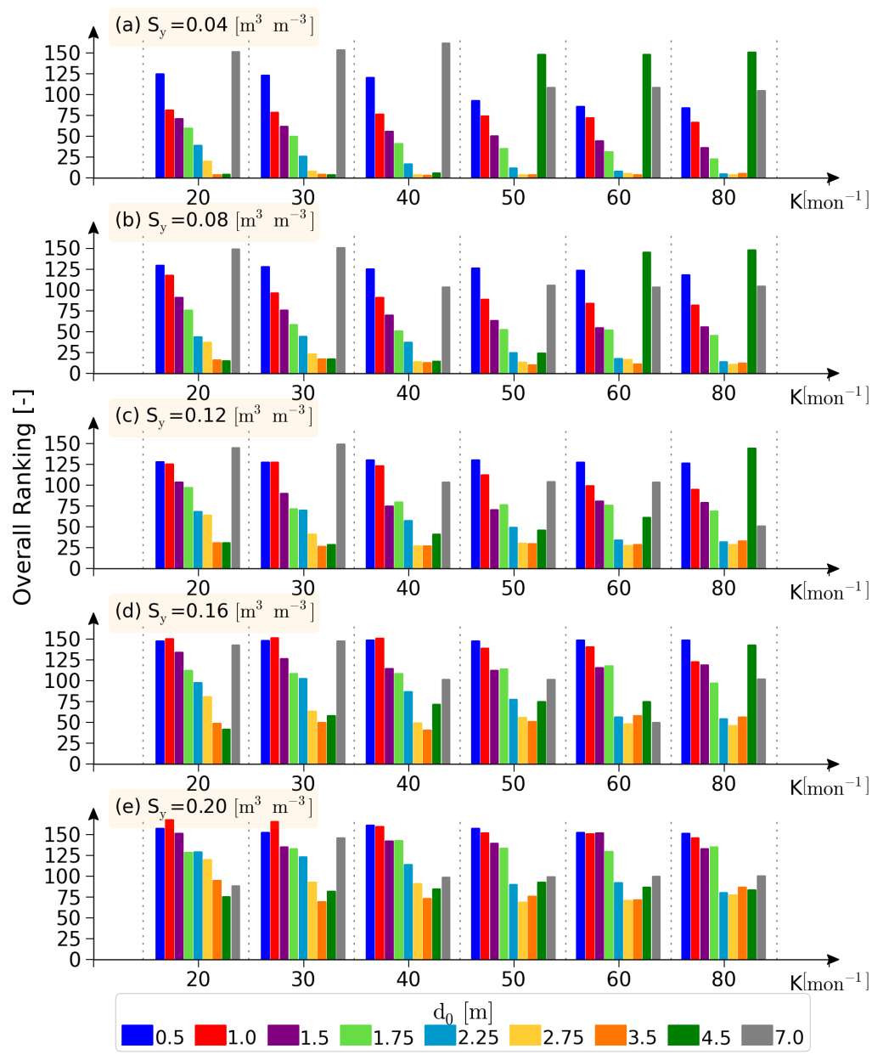
Figure 2. The overall ranking (OR) of each parameter set in the Illinois simulations.

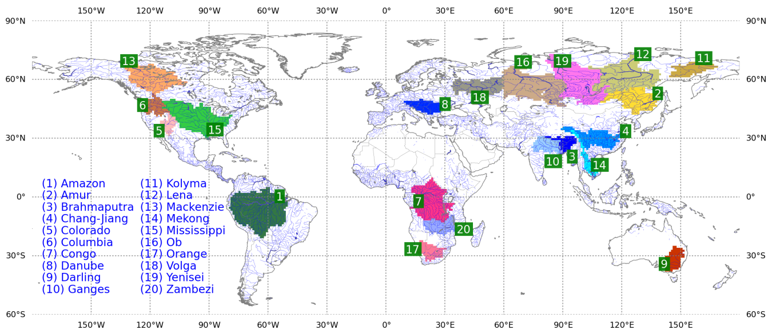
Figure 3. The 20 selected large river basins of this study.

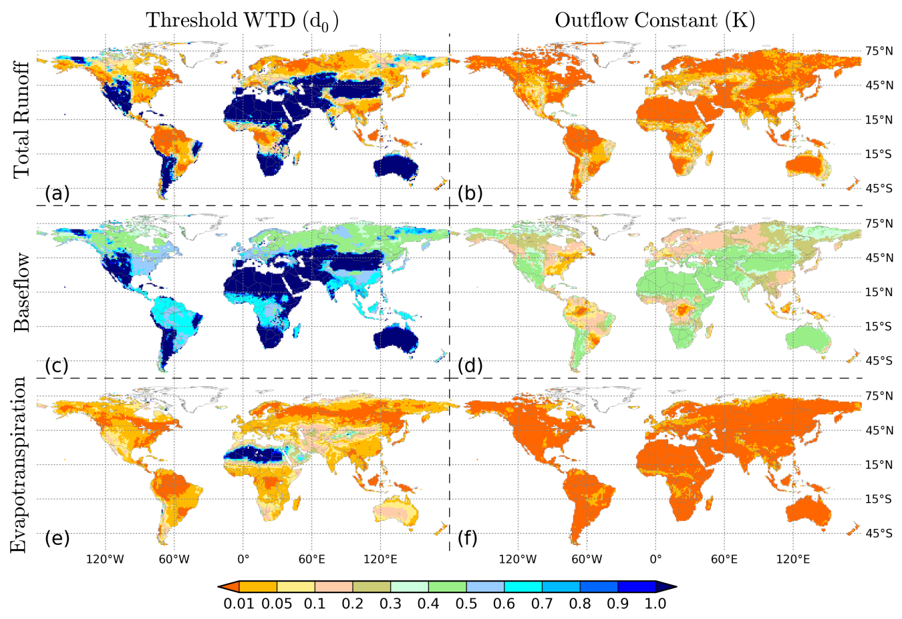
Figure 4. The relative deviation from the mean of the simulations of (a) total runoff for different
d₀ (b) total runoff for different K, (c) baseﬂow for different d0, (d) baseﬂow for different K, (e)
evapotranspiration for different d0 and (f) evapotranspiration for different K.

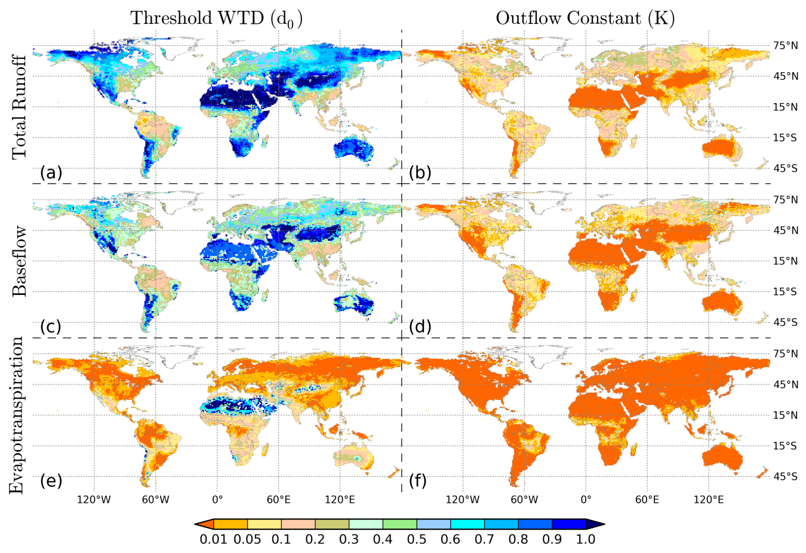
Figure 5. The relative deviation of the coefficient of variation of the simulations of (a) total runoff for different d0, (b) total runoff for different K, (c) baseﬂow for different d0, (d) baseﬂow for different K, (e) evapotranspiration for different d0, and (f) evapotranspiration for different K.

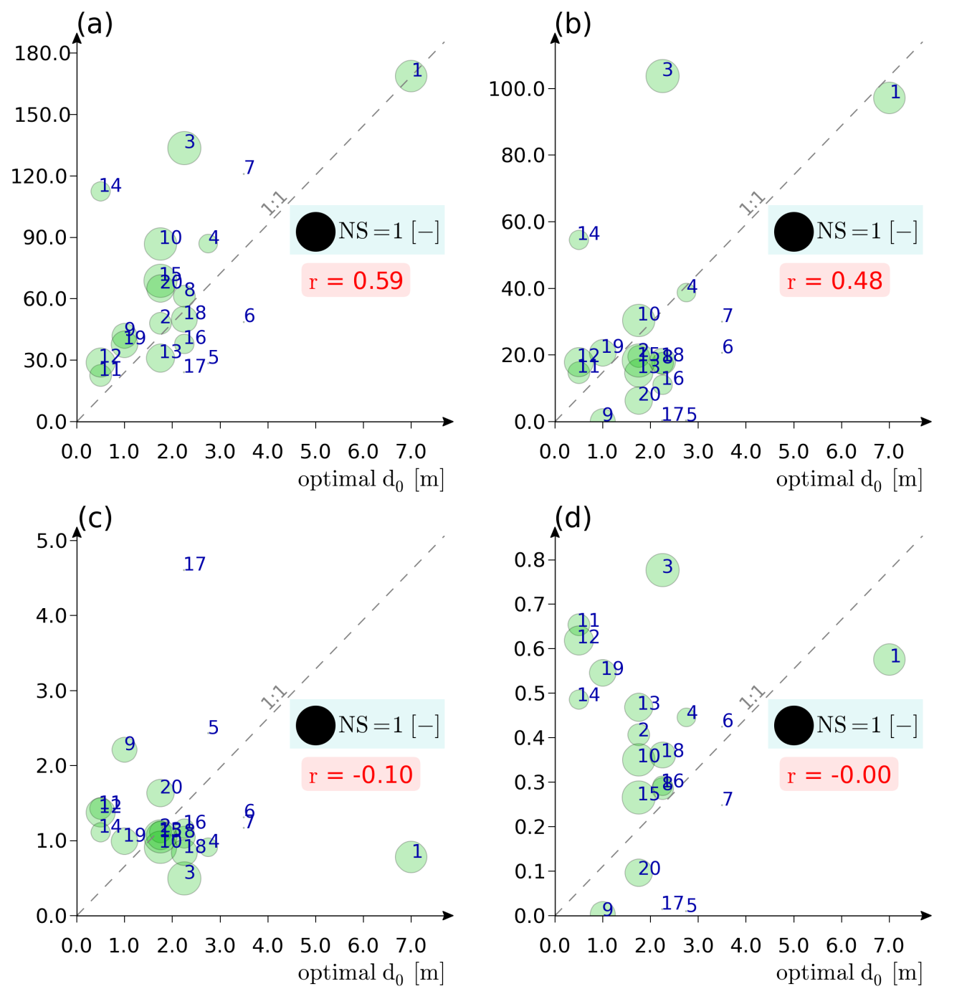
Figure 6. The scatter plot of the optimal d0 against (a) mean precipitation, (b) observed river discharge, (c) Budyko's dryness index, and (d) runoff ratio in the selected river basins. Numbers beside the circles indicate the basin ID in Figure 3. Size of the circle denotes NS coefficient. For basins 5 (Colorado), 6 (Columbia), 7 (Congo), and 17 (Orange), the size of circle is non-representative as NS are negative. R is the correlation coefficient.
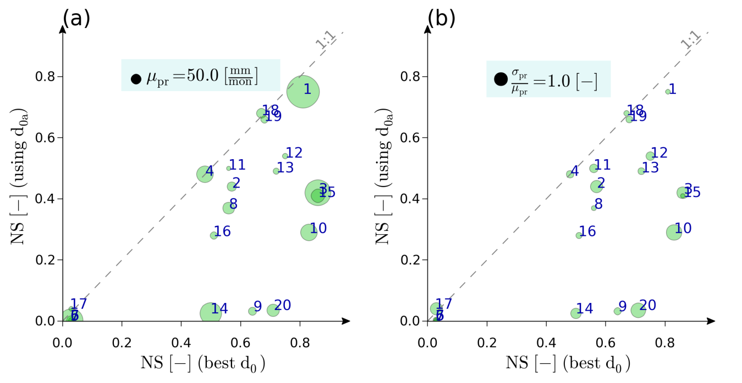
Figure 7. The scatter plot of NS obtained from river discharge simulations using the optimal d0 and d_{0a} (equation (5)) with size of the circle indicating (a) mean monthly precipitation, and (b) the coefficient of variation of precipitation in the selected river basins. Numbers beside the circles indicate the basin ID in Figure 3.

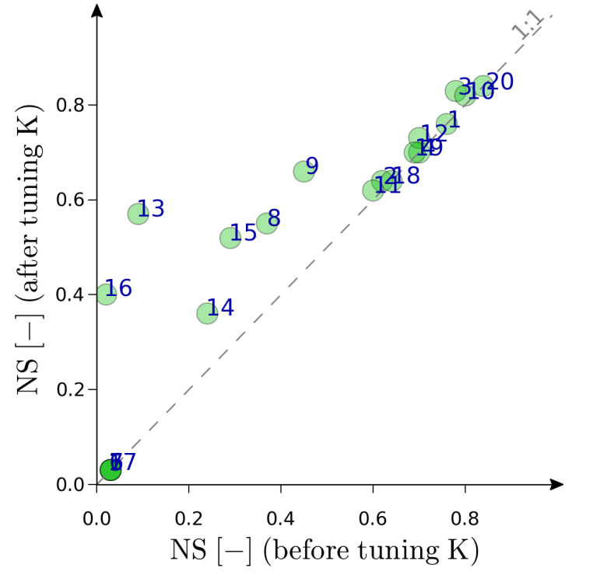
Figure 8. The scatter plot of NS obtained from river discharge simulations using d0b (equation (6)), and (a) using the optimal d0, (b) using d(equation (5)) in the selected river basins. Numbers beside the circles indicate the basin ID in Figure 3.

