The parameterization of saturated-unsaturated zone interaction in the estimation of land surface hydrological fluxes
Sujan KOIRALA¹, Pat YEH¹, Taikan OKI¹, and Shinjiro KANAE²
1) Institute of Industrial Science, University of Tokyo, Tokyo 153-8505, Japan
2) Graduate School of Information Science and Engineering, Tokyo Institute of Technology, Tokyo, 152-8552, Japan

- INTRODUCTION
Most of the Land Surface Models (LSMs) employ a soil model with a simplified lower boundary condition of free (gravity) drainage or zero flux; hence the interaction between the groundwater (GW) and soil moisture is largely neglected. In addition to atmospheric sources of surface water currently used in LSMs, GW sources are considered to be necessary to estimate runoff and evaporation correctly and improve water balance computation.
In this study, we illustrate the effect of parameterization of saturated-unsaturated zone interaction on the prediction of hydrological fluxes by using a coupled LSM-GW model. The parameterization directly affects the exchange of moisture flux across the saturated-unsaturated zone interface and potentially alters the prediction of the water table depth, soil moisture, runoff and evapotranspiration.
- MODELS AND METHODOLOGY
The LSM used here, the Minimal Advanced Treatments of Surface Integration and RunOff, (MATSIRO) (Takata et al., 2003) is a physically- based LSM, which calculates stomatal resistance from a photosynthetic scheme on the basis of physiology. The energy balance is solved at four surfaces (snow-free and snow-covered portions of ground surface and canopy surface, respectively) in a grid cell.
However, there is no explicit representation of GW dynamics in MATSIRO. Hence, an unconfined aquifer is integrated below the unsaturated soil column, the thickness of which is time-dependent, and varies with the location of water table. The water table acts as an interface between the unsaturated and saturated zones in the soil column. The water balance equation for the unconfined GW aquifer (Yeh et al., 2005a) can be represented as,
$S_{y}\frac{\text{dH}}{\text{dt}}=I_{\text{gw}}−Q_{\text{gw}}$
where $S_{y}$is the specific yield of aquifer, $H$is the water table depth, and $Q_{\text{gw}}$ is the outflow (base runoff).
$I_{\text{gw}}$is the net drainage flux to/from the GW reservoir and can be estimated as,
$$I_{\text{gw}}=k_{\text{soil}}−q_{\text{cap}}$$
where$k_{\text{soil}}$ is the downward gravity drainage flux to the GW reservoir, equal to the unsaturated hydraulic conductivity of the lowermost unsaturated layer; $q_{\text{cap}}$ is the upward capillary flux from the GW reservoir to the soil moisture column above.
In this study, we attempt to analyze the effect of different parameterization of $q_{\text{cap}}$on the land surface hydrologic simulation. In the first case (hereafter case A), the capillary flux from GW reservoir to soil moisture column is estimated using the Eagleson’s capillary flux equation given as,
$q_{\text{cap}}=k_{\text{sat}}⋅α⋅{\left(\frac{ψ_{\text{ae}}}{Z_{g}}\right)}^{β}$$β=2+3b$ ,$α≈1+\frac{32}{β−1}$
$ψ_{\text{ae}}$ -air entry pressure, $k_{\text{sat}}$ - saturated hydraulic conductivity for the soil type,$z_{g}$ - water table depth,$b$- Clapp-Hornberger’s coefficient. In the above empirical equation, water table is the only variable and all other parameters are constants for a particular type of soil.
In the second case (hereafter case B), $q_{\text{cap}}$ is estimated using the gradient of matric potential between the saturated zone and the lowermost unsaturated layer as following,
$$q_{\text{cap}}=k_{\text{soil}}⋅\frac{dψ}{\text{dz}}$$
where $dψ$is the difference of matric potential and $\text{dz}$ is the centre-to-centre distance between saturated zone and the lowermost layer of unsaturated soil column. In this case, the gradient is dependent on the actual moisture content of the soil layer, hence representing a more realistic condition.
For each parameterization, global simulation is carried out driven by NCC (National Centers for Environmental Prediction/National Center for Atmospheric Research Corrected by Climate Research Unit) near-surface meteorological data with a 6-hourly time step from 1980 to 2000 and a spatial resolution of 1.0ºx1.0º.
Only the Amazon, Congo, and Ganges are selected as target river basins to study the effect of parameterization in different hydroclimatic regions. The first 5-year simulation is treated as spin-up years and not included in the analysis.
- RESULTS AND DISCUSSIONS
Fig. 1 shows 1985-1999 mean seasonal cycles of hydroclimatic variables in all target river basins.
In case of the Amazon (lines with circular markers in Fig. 1), the water table is shallow; therefore capillary flux in case A is consistently larger than that in case B (Fig. 1-d) because of the non-linear dependence of capillary flux to the water table depth in case A. More so, the moisture gradient between unsaturated layer and saturated zone is small due to high moisture content of unsaturated soil column (Fig. 1-l). Hence, smaller capillary flux is simulated in case B. However, the net GW recharge does not change significantly because of the negative feedback mechanism of enhanced gravity drainage due to increased soil moisture resulting from increased upward flux from GW reservoir. Consequently, the changes in water table depth (Fig. 1-f) and total runoff (Fig. 1-c) for both cases are negligible.
However, for the Congo basin (lines with triangular markers in Fig. 1), case B produces larger capillary flux than case A (Fig. 1-d) due to relatively dry unsaturated zone soil moisture as shown in Fig. 1-l. This large gradient enhances the capillary flux in case B. The net GW recharge decreases marginally (Fig. 1-e), resulting in deeper water table (Fig. 1-f) and smaller baseflow (Fig. 1-d) with a fractional increase in total evapotranspiration (Fig. 1-h), as depicted by the long-term mean values given in the parenthesis in the respective figures.
Furthermore, for the Ganges basin (lines with square markers in Fig. 1) characterized by the strong seasonality of precipitation (Fig. 1-a), the effect of parameterization is significant. In dry season when soil moisture is low, the matric potential-based case B produces a larger capillary flux than the water table-based case A (Fig. 1-g). This enhanced upward water flux outweighs downward gravity drainage, resulting in net upward flux from GW reservoir to unsaturated soil column (Fig. 1-e).This further leads to wetter root-zone soil moisture (Fig. 1-l) and increases bare soil evaporation (Fig. 1-i) and hence total evaporation (Fig. 1-h). In wet season when most of the precipitation (Fig. 1-a) occurs, the water table is shallow (Fig. 1-d) and soil moisture content is higher (Fig. 1-k), which leads to higher capillary flux in case A than in case B (Fig. 1-g). Further, it can be noted that the total soil moisture (Fig 1-k) remains nearly constant for both parameterizations in Ganges. This highlights the necessity of an improved parameterization for the partitioning between GW and soil moisture storages.
- CONCLUSIONS
In dry river basins with low precipitation or strong seasonal variability in precipitation, the hydrological prediction is more sensitive to the parameterization when the unsaturated soil column is relatively dry. For wet basins, even though the upward flux from the saturated to unsaturated zone is altered, the negative feedback mechanism of downward flux balances the net flux and hence the sensitivity is relatively low. However, due to the lack of observational data of the fluxes directly involved in the process, it is not a trivial task to judge which parameterization is more suitable. Nevertheless, the choice of the parameterizations would alter the simulation of land-surface hydrological fluxes, which emphasizes the necessity of incorporating an explicit representation of GW dynamics in LSMs.
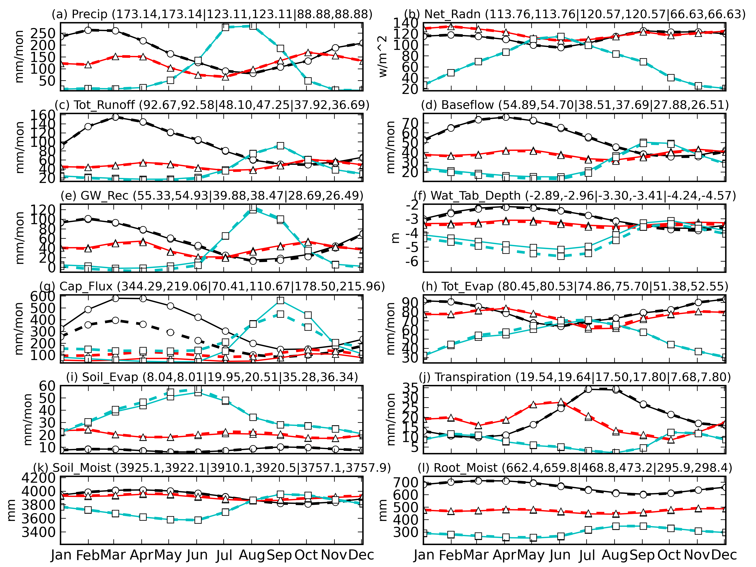
Fig. 1: Hydroclimatic Variables in the Amazon basin- Lines with Circular markers; the Congo basin - Lines with Triangular markers; and the Ganges basin- Lines with Square markers; for case A- Solid line and case B- Broken lines
(Values in parenthesis indicate mean monthly values for (case A, case B) in the Amazon, Congo, and Ganges river basins respectively)

- REFERENCES
Takata, K., Emori, S. and Watanabe, T.: Development of minimal advanced treatments of surface interaction and runoff, Global and Planetary Change, Vol.38, pp.209-222, 2003.
Yeh, P. J.-F., Eltahir, E. A. B.: Representation of water table dynamics in a land surface scheme. Part I: Model development, J. Clim. Vol.18, pp.1861-1880, 2005a
Keywords: Groundwater, Land Surface Model, Capillary Flux, Water Table Depth

